Keith JHaeron M. Cayatoc

B.I.T STUDENT

Nelson Marlborough Institute of Technology

DAT602 – Assignment

Tutor: Todd Cochrane

Table of Contents

Assignment 1 Milestone One 3

Game Description 3

Core Idea and Gameplay 3

Player Registration/Login 3

Graphical Design 4

Logical Entity Relationship Diagram 23

CRUD Table 25

DDL SQL Scripts 27

C# .Net Application Prototype 28

Assignment 2 Milestone Two 29

1. Introduction 29

2. TSQL Procedures Implementation 29

2.1 Player Login (Including lockout) 29

2.2 Player Registration 31

2.3 Player Deletes Own Account 32

2.4 Laying Out Tiles on Game Board 33

2.5 Placing an Item on a Tile 34

2.6 Player Gameplay Movement 35

2.7 Game Play Scoring 37

2.8 Player Acquiring Inventory (Pickup) 38

2.9 Item (NPC Effect) Movement 39

2.10 Admin Kill Running Games 41

2.11 Admin Add New Players 42

2.12 Admin Update Player Data 43

2.13 Admin Delete Player 44

3. DAO Methods Implementation 45

3.1 Overview 45

3.2 AuthDAO Class 45

3.3 GameDao Class 47

3.4 AdminDao Class 49

4. GUI Components Implementation 51

4.1 LoginForm 51

4.2 RegisterForm 53

4.3 GameForm 54

4.4 AdminForm 59

5. Testing Evidence 64

5.1 Comprehensive Test Script 64

5.2 GUI Testing 64

Assignment 2 Milestone Three 65

1. TSQL Concurrency and transactions and C# Code Refactoring 65

2. Concurrency Management in MySQL 105

Introduction 105

Pessimistic Locking 105

Optimistic Locking 106

Timestamp Ordering 107

Concurrency Management in .NET C# Database Connections 109

LINQ to SQL Connections 111

Entity Framework Connections 112

Comparison: MySQL Stored Procedures vs .NET Approaches 113

Conclusion 114

References 115

# Assignment 1 Milestone One

## Game Description

### Core Idea and Gameplay

The Raze is a multiplayer turn-based, post-apocalyptic survival game set in a collapsed world where players fight for control over territory and resources. The game takes place on a grid-based map where players take turns to either move, scavenge, loot, or attack. Each player starts with minimal supplies like a bandage for health, an apple for food, and a knife for defending or attacking. Players must navigate the map to find better weapons, food, armour, and healing items like med kits/bandages. The system architecture follows a data-driven model where all gameplay logic such as player movement, scoring, and inventory updates is executed through SQL stored procedures. This ensures that the database controls the game state, maintaining fairness and consistency between all connected clients.

Players can use their turn to:

1. Move to an adjacent tile.
2. Pickup items.
3. Attack another player or mutant if nearby.
4. Drop or use items.
5. Interact with the environment such as looting a broken-down vehicle or abandoned building.

Each tile may contain loot, enemies or be empty. Combat is also turn-based requiring strategic use of inventory and positioning. The goal is SURVIVAL. Players has the freedom to form alliances, betray others, or complete quests that sometimes appear randomly for bonus items. The game does not have a defined end state instead, it rewards long-term survival, adaptability, and smart decisions made during each turn.

### Player Registration/Login

When a player opens the game for the first time, a registration/login screen will be displayed and in this screen they can either create a new account by inputting their username, email, and password or login with their account using the username and password they registered with, players will only have 5 attempts to login before getting locked out of the game in which they need to contact an administrator in order to unlock their accounts and be able to change their password and login again.

## Graphical Design

**Login Screen**

|  |
| --- |
| Storyboard 1 – This is what the player will see when opening the application for the first time.  User Story: As a player, I want to log into my account securely so that my saved progress and scores are loaded safely. |
|  |
| 1.1 – Textbox for players to type their username.  1.2 – Textbox for players to insert their password after putting in their username.  1.3 – A button that can be clicked by the player to login to the game, if an account is found in the database it logs in the player. If a player makes 5 unsuccessful attempts. |

**Player Lockout Attempt Warning**

|  |
| --- |
| Storyboard 1.2 – A warning message will display to let the user know how much attempts they have left when a user fails to login for the first time. |
|  |
| 1.2.1 – A user types in their password (accidentally types in the wrong password/typo).  1.2.2 – A user clicks on the Login Button.  1.2.3 – The warning message pops up after the first attempt of incorrectly typing in password. |

**Player account gets locked**

|  |
| --- |
| Storyboard 1.3 – After multiple failed attempts a message gets displayed to the user. |
|  |
| 1.3 – When a user logins into their account and fails 5 times a warning message will popup notifying the user that their account has been locked and would then need an admin intervention. |

**Username Not Found Prompt**

|  |
| --- |
| Storyboard 1.4 – A prompt modal pops up to the user when they try to login to an account that does not exist in the database. |
|  |
| 1.4.1– A quick message with an error icon to depict that there is something wrong to the user.  1.4.2 – When the user clicks on the “Yes” button, this will take the user to the registration form page.  1.4.3 – When the user clicks on the “No” button, it will return the user to the login page. |

**Player Registration**

|  |
| --- |
| Storyboard 2 - This screen allows new players to register an account by entering their email, username, and password. If registration is successful the player is automatically logged in.  User Story: As a new player, I want to create an account using my email and password, so that I can participate in multiplayer games |
|  |
| 2.1 – Textbox for players to type their email.  2.2 – Textbox for players to type their password.  2.3 – A register button that saves the player details to the database and logs them in.  2.4 – A cancel button that returns the user to the login screen without saving.  2.5 – Textbox for players to type their desired username, this autofills if the player came from the login page. |

**Player Deletes Own Account**

|  |
| --- |
| Storyboard 3 - This screen allows a logged-in player to permanently delete their account. Deleting the account removes all stored game data from the database and cannot be undone.  User Story: As a player, I want to have the ability to permanently delete my account so that my data and progress are removed from the system. |
|  |
| 3.1 – A delete account button that calls a procedure to remove player from database.   * Confirmation popup displaying a message: “You can’t reverse this action!”. * If confirmed, account gets deleted and returns the player to the login screen.   3.2 – A back to main menu button that returns player to game lobby without making changes. |

**Laying Out Tiles on a Game Board**

|  |
| --- |
| Storyboard 4 - This screen is used during game setup to generate and lay out the tiles that make up the board. Each tile represents a location such as ruins, street, safe house, and items. The layout is stored in the database so all players in the session see the same board.  User Story: As an admin, I want to lay out tiles on the game board so that a consistent map layout is generated for all players. |
|  |
| 4.1 – Tile Palette: Buttons representing different tile types the admin can select.  4.2 – Board Grid: The tile map where chose tiles are placed.  4.3 – Controls:   * Place Tile – Adds selected tile to chosen square. * Clear Tile – Removes a tile. * Save Layout – Writes tile positions into the database for gameplay use. * Cancel – Returns to main lobby.   **Gameplay Flow Notes:**  Admin (or system) generates the board.  Each tile placement updates DB (INSERT into Tile table with type plus coordinates).  Saved board layout becomes the map for all players in that session. |

**Placing an Item on a Tile**

|  |
| --- |
| Storyboard 5 – This screen allows the admin or game setup system to place items onto specific tiles of the map. Each item is stored in the database with its type, position, and availability. Players can later pick these up during gameplay.  User Story: As an admin, I want to place items on specific tiles so that players can discover and collect them during gameplay. |
|  |
| 5.1 – Item Palette: List of items available to be placed could expand later to ammo, tools and rare loot.  5.2 – Board Grid: Clickable grid where a selected tile shows item placed with an icon of a food, medkit, food etc.  5.3 – Controls:   * Place Item - Places selected item on chosen tile. * Remove Item - Deletes item from the tile. * Save Items - Writes all items and their coordinates to the database. * Cancel - Returns to lobby without saving.   **Gameplay Flow Notes:**  Item placement is saved as rows in the DB INSERT into Item table with type + TileID.  Each tile can hold multiple items or limited by the design like max 1 item per tile.  Players later use CRUD operations to READ and DELETE items when picking them up. |

**Game Lobby**

|  |
| --- |
| Storyboard 5.2 – The screen players that has an existing account see before they play the game. |
|  |
| 5.2.1- Join Lobby button to let players join lobby  5.2.2 – Create Lobby button to let players create their own lobby |

**Player Gameplay Movement**

|  |
| --- |
| Storyboard 6 - This screen is where players move across the grid-based map during their turn. Movement is limited to adjacent tiles (up, down, left, right). When a player clicks on a tile and confirms movement the system updates their position in the database.  User Story: As a player, I want to move to adjacent tiles so that I can explore the environment and interact with objects or enemies. |
|  |
| 6.1 – Player Status Panel: Displays HP, Score, Inventory icons.  6.2 – Board Grid: Current tile-based map. Player (P#) position shown. Adjacent tiles are clickable for movement.  6.3 – Action Buttons:   * Move - Player selects adjacent tile → database updates Player_Position table. * Pick Up - If item exists on tile, player can add it to inventory (handled in Storyboard 8). * Use Item - Consumes inventory item heals or food. * End Turn - Ends player’s turn, DB logs state, next player’s turn begins.   **Gameplay Flow Notes:**  Movement is validated (must be a legal tile).  Each move updates DB with player’s new coordinates.  If tile has enemy, combat triggers if it’s an item an option to pick up appears.  Once End Turn is clicked other players cannot move until their turn. |

**Player Gameplay Scoring**

|  |
| --- |
| Storyboard 7 – Players can gain or lose points based on the following actions: picking up valuable loots, taking damage or losing an item, and killing a npc enemy or enemy player. The scoring system is tied to the database and updates after each action.  User Story: As a player, I want to gain or lose points from my actions so that my performance is reflected in the score. |
|  |
| 7.1 – Board Grid: Shows player position, items, and enemies.  7.2 – Event Log: Displays real-time updates of actions with point changes.  7.3 – Score Display: Updates dynamically after each action and is written to the database.  **Gameplay Flow Notes:**  Each CRUD operation triggers a stored procedure to update score for example, UPDATE Player SET Score = Score + 10.  Event log helps players see how they gained or lost points.  Scores are persistent across sessions stored in DB. |

**Player Gameplay Acquiring Inventory**

|  |
| --- |
| Storyboard 8 - When a player moves onto a tile containing an item, they can choose to pick it up. The item is removed from the tile and added to the player’s inventory in the database.  User Story: As a player, I want to pick up items and store them in my inventory so that I can use them strategically later. |
|  |
| 8.1 – Inventory Slots: Shows what the player currently carries.  8.2 – Board Grid: Player standing on a tile with an item (medkit from the image above)  8.3 – “Pick Up Item” Button: Runs procedure to transfer item from Tile to Inventory.  8.4 – Event Log: Shows confirmation of item pickup and DB update.  **Gameplay Flow Notes:**  When player chooses Pick Up:   * DB DELETE from Tile_Item table * DB INSERT into Inventory table   If inventory is full the system will show error message in log (“No space in backpack”).  Item immediately available in inventory UI for later use. |

**Item (NPC Effect) Movement**

|  |
| --- |
| Storyboard 9 - Some non-player elements in the game (mutants) move automatically between turns. Their new position is updated in the database so all players see consistent world state.  User Story: As the system, I need to automatically move NPCs or roaming items so that the game world stays dynamic. |
|  |
| 9.1 – NPC on Grid: Mutant (E) is visible as an icon on the map.  9.2 – NPC Movement Log: Shows what moved where; recorded in DB.  9.3 – Controls:   * End Turn which triggers NPC movement procedure in DB. * View NPC Log: optional panel listing recent movements.   **Gameplay Flow Notes:**  NPCs move after player ends their turn.  Database handles NPC updates:   * UPDATE Tile_Item SET TileID = NewTile for roaming loot/creatures.   If NPC moves into player’s tile a combat or event is triggered. |

**Item Location**

|  |
| --- |
| Storyboard 10 - This screen shows how items are placed and tracked on the game board. The database keeps record of each items location so if a player drops or leaves an item, it stays on that tile until picked up by another player. |
|  |
| 10.1 – Board Grid: Items are shown on specific tiles as icons  10.2 – Item Log: Tracks where items are currently located in DB. Example: “Water Bottle at Tile B4.”  10.3 – Controls:   * Pick Up button removes item from tile and inserts into player inventory. * Drop Item button deletes item from inventory and inserts into tile. * End Turn button moves play to next player.   **Gameplay Flow Notes:**  Items have persistent locations in DB until picked up.  Dropping items creates opportunities for scavenging by others.  CRUD operations:   * INSERT INTO Inventory when picked up * DELETE FROM Tile_Items when removed from tile * INSERT INTO Tile_Items when dropped |

**Admin: Kill Running Games**

|  |
| --- |
| Storyboard 11 - Admin can view all active sessions and immediately terminate a selected game. This updates game status in the DB, closes related sessions, and returns affected players to the lobby. |
|  |
| 11.1 – Active Games table: lists currently running/pending games (sortable).  11.2 – Selected Game details: confirms which game will be affected.  11.3 – Controls:   * Kill Game button sets game status to ended/inactive, ends any open sessions, forces players to lobby. * Refresh button re-queries active/pending games. * Back to Lobby buttons exits admin panel. |

|  |
| --- |
| Storyboard 11.2 – A popup notification when an admin kills a running game. |
|  |
| 11.1.1 – Displays a warning message to the admin.  11.1.2 – A button to confirm that the admin wants to kill a game.  11.1.3 – A button to cancel operation. |

**Admin: Add New Player**

|  |
| --- |
| Storyboard 12 - Admin creates a new player account. On save, the user is inserted into the Players table with defaults as shown below. |
|  |
| 12.1 – Username: Required. Must be unique  12.2 – Email: Required. Basic format validation.  12.3 – Password: Required. Show/hide toggle optional.  12.4 – Admin User: Optional privilege flag.  12.5 – Locked: Optional; default unchecked (new accounts unlocked).  12.6 – Actions:   * Save: Validates inputs, inserts record, confirms success, returns to Admin list. * Cancel: Discards changes, returns to Admin list. |

**Admin: Update Player Data**

|  |
| --- |
| Storyboard 13 - Admin can select a player from the list and edit details like username, email, password, or status flags. The updated record is saved to the database. |
|  |
| 13.1 – Select Player: Choose target player from list/search.  13.2 – Username: Editable text field.  13.3 – Email: Editable text field.  13.4 – Password Reset: Option to update password or auto-generate new one.  13.5 – Admin User Checkbox: Toggle admin status.  13.6 – Locked Checkbox: Toggle lock/unlock account.  13.7 – Score Field: Manually adjust score if needed.  13.8 – Actions:   * Save Changes button updates DB record. * Cancel button discards changes and returns to list. |

**Admin: Remove Existing Player**

|  |
| --- |
| Storyboard 14 - Admin can permanently delete a player account from the system. This removes the players record from the database and all associated data (inventory, scores, sessions). |
|  |
| 14.1 – Select Player: Dropdown/search to choose a player.  14.2 – Player Info: Displays details of selected player before deletion.  14.3 – Warning Message: Confirms that this is irreversible.  14.4 – Actions:   * Delete Player button removes record from DB. * Cancel button returns to admin list without changes. |

## Logical Entity Relationship Diagram

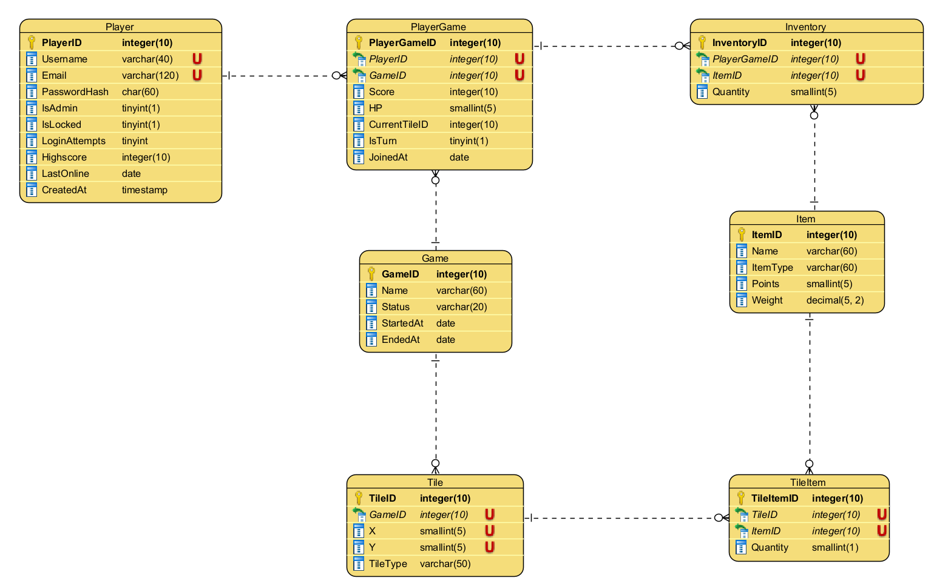

|  |  |  |  |
| --- | --- | --- | --- |
| **Table (entities)** | **Description** | **Attributes** | **Relationships** |
| **Player** | Holds account/profile and login state. | PlayerID (PK), Username (U), Email (U), PasswordHash, IsAdmin, IsLocked, LoginAttempts, Highscore, LastOnline, CreatedAt | A player can have one or many player game. |
| **Game** | One running or finished match. | GameID (PK), Name, Status, StartedAt, EndedAt | One game has many player game. |
| **Tile** | Grid cells that belong to a game, one row per coordinate. | TileID (PK), GameID (FK→Game), X, Y, TileType | A game has one to many tile. |
| **PlayerGame** | A player’s participation in a specific game (score/state per match). | PlayerGameID (PK), PlayerID (FK→Player), GameID (FK→Game), Score, HP, CurrentTileID (FK→Tile), IsTurn, JoinedAt. | A player can have one to many player game, a game can have many playergame that contains many tile where players can stand on. |
| **Item** | Item catalogue for example bandage, weapon, medkit. | ItemID (PK), Name, ItemType, Points, Weight | An inventory can have on or many item. |
| **TileItem** | Items placed on the board and their counts at a specific tile. | TileItemID (PK), TileID (FK→Tile), ItemID (FK→Item), Quantity | A tileitem contains one to many items. |
| **Inventory** | What a player in a given game is carrying. | InventoryID (PK), PlayerGameID (FK→PlayerGame), ItemID (FK→Item), Quantity | An inventory can have one to many item. |

## CRUD Table

|  |  |  |  |
| --- | --- | --- | --- |
| **Process** | **Table** | **Attribute(s)** | **Operation (CRUD)** |
| Player login incl. lockout | Player | Username | R |
|  | Player | PasswordHash | R |
|  | Player | LoginAttempts | U |
|  | Player | IsLocked | U |
|  | Player | LastOnline | U |
| Player registration | Player | PlayerID | C |
|  | Player | Username | C |
|  | Player | Email | C |
|  | Player | PasswordHash | C |
|  | Player | IsAdmin/IsLocked/LoginAttempts | C |
| Player deletes own account | Player | PlayerID (row) | D |
| Laying out tiles | Game | GameID | R |
| Laying out tiles | Tile | TileID | C |
|  | Tile | (GameID,X,Y,TileType) | C |
| Placing an item on a tile | TileItem | TileItemID | C |
|  | TileItem | (TileID,ItemID) | C |
| Player gameplay movement | PlayerGame | CurrentTileID | U |
|  | PlayerGame | IsTurn | U |
| Player gameplay scoring | PlayerGame | Score | U |
| Acquire inventory | Inventory | InventoryID | C |
|  | Inventory | (PlayerGameID,ItemID,Qty) | C |
| Acquire inventory | TileItem | TileItemID | D |
| Item (NPC effect) movement | TileItem | TileID | U |
| Item location (query) | TileItem | (TileID,ItemID) | R |
| Item drop to tile | Inventory | InventoryID | D |
| Item drop to tile | TileItem | (TileID,ItemID) | C |
| Admin kill running game | Game | Status | U |
| Admin kill running game | PlayerGame | IsTurn | U |
| Admin add new player | Player | (Username,Email,PasswordHash,IsAdmin,IsLocked) | C |
| Admin update player data | Player | (Username,Email,PasswordHash,IsAdmin,IsLocked,HighScore) | U |
| Admin remove existing player | Player | PlayerID (row) | D |

Several processes touch the same table for example, Player for login, registration, and admin edit. To avoid repeating entire rows, entries are grouped by process and list the specific columns affected with the corresponding CRUD operation(s). Each process below also has a brief description so the marker can see the intent and data impact clearly

**Rationale for the CRUD analysis**

1. **Game state separation:** Player stores account/security, PlayerGame stores per‑match state HP, score, current tile, and whose turn it is. That lets one player join many games without clashing data.
2. **Board persistence:** Tile with unique GameID, X, Y captures the grid, TileItem persists “items on the ground” independent of players and Inventory persists “items held by a player in a game”. These cleanly supports pickup/drop.
3. **Integrity & cascades:** FKs with CASCADE/RESTRICT/SET NULL keep data consistent when players or games are removed.
4. **Security & policy:** Login touches only Player, implements lockout, and never exposes raw passwords, hash only.
5. **Turn‑based rules:** Movement updates PlayerGame.CurrentTileID only when it’s the player’s turn and the target tile is legal.

Each CRUD process corresponds to a functional use case within gameplay or administration. For example:

* Player login including lockout reads the player record, increments failed login attempts and updates lock status after five tries.
* Player registration inserts a new record while validating username and email uniqueness.
* Placing an item on a tile inserts into TileItem table, updating quantity if an item already exists.
* Player gameplay movement updates PlayerGame.CurrentTileID while ensuring only adjacent moves are allowed.
* Game scoring updates the players score and recalculates high scores.
* Acquiring inventory deletes from TileItem and inserts into Inventory.

## DDL SQL Scripts

The script is uploaded to moodle with the file name: DAT602-Assessment-One-M1-SQL-Script

## C# .Net Application Prototype

The C# Github Repository will be uploaded to moodle.

# Assignment 2 Milestone Two

## 1. Introduction

This part of the report documents the implementation of Stage 2 Milestone Two of the database application project. All 12 CRUD processes identified in Assignment 1 have been implemented through TSQL stored procedures, C# Data Access Object also known as DAO methods, and GUI components.

The game “The Raze” is a multiplayer turn-based survival game where players move on a grid-based map, collect items, and compete for survival. This milestone focuses on creating the functional backend procedures and connecting them to a working GUI interface.

## 2. TSQL Procedures Implementation

### 2.1 Player Login (Including lockout)

**Procedure Name:** sp_login_player

**Purpose:** Authenticates a players login credentials and manages account lockout after 5 failed attempts.

**Parameters:**

* IN p_username VARCHAR(40) – The players username
* IN p_passwordhash CHAR(64) – SHA256 hash of the password
* OUT p_status VARCHAR(20) – Returns “OK”, “LOCKED”, “BADPASS”, or “UNKNOWN”

**SQL Code:**

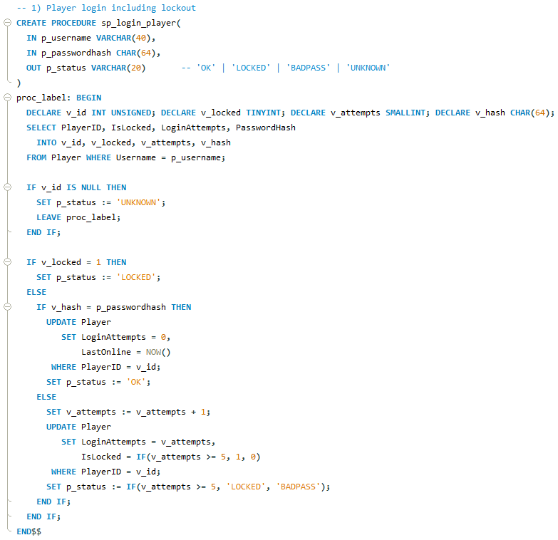

**Test Call:**

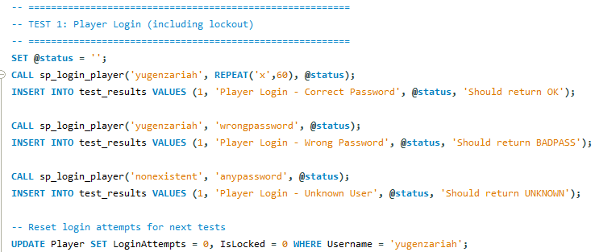

**Test Results:**

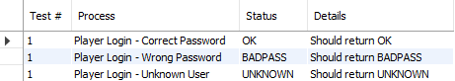

The procedure checks if the username exists, verifies if the account is locked, validates the password hash, and updates login attempts. After 5 failed attempts the account is automatically locked.

### 2.2 Player Registration

**Procedure Name:** sp_register_player

**Purpose:** Creates a new player account in the system.

**Parameters:**

* IN p_username VARCHAR(40)
* IN p_email VARCHAR(120)
* IN p_passwordhash CHAR(64)

**SQL Code:**

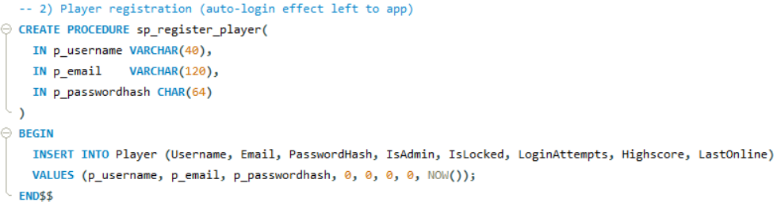

**Test Call:**

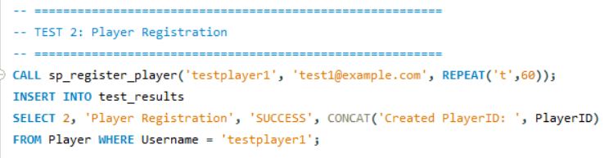

**Test Result:**

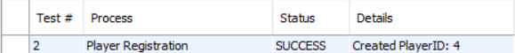

Inserts a new player record with default values for IsAdmin(0), IsLocked(0), LoginAttempts(0), and sets LastOnline to current timestamp.

### 2.3 Player Deletes Own Account

**Procedure name:** sp_admin_delete_player

**Purpose:** Allows a player to permanently delete their account. (This uses the admin delete procedure but can be called by the player for their own account)

**Parameters:**

* IN p_playerId INT UNSIGNED

**SQL Code:**

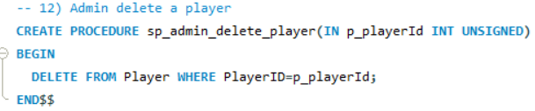

**Test Call:**

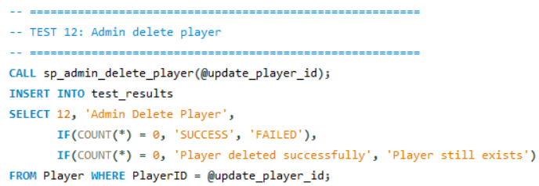

**Test Result:**



Deletes the player record. Due to the CASCADE constraints, all related PlayerGame, Inventory records are automatically removed.

### 2.4 Laying Out Tiles on Game Board

**Procedure name:** sp_reset_board

**Purpose:** Clears and regenerates the tile grid for a specific game.

**Parameters:**

* IN p_gameId INT UNSIGNED
* IN p_width INT
* IN p_height INT

**SQL Code:**

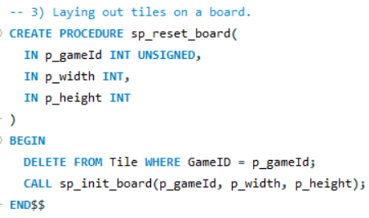

**Test Call:**

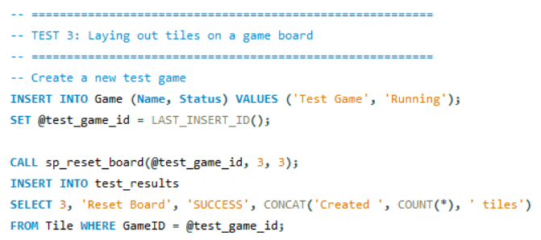

**Result:**



First deletes all existing tiles for the game, then calls sp_init_board which creates a grid of tiles with specified dimensions. The home tile is marked at coordinates (0,0).

### 2.5 Placing an Item on a Tile

**Procedure Name:** sp_place_item_on_tile

**Purpose:** Places or adds items to a specific tile on the game board.

**Parameters:**

* IN p_tileId INT UNSIGNED
* IN p_itemId INT UNSIGNED
* IN p_qty SMALLINT

**SQL Code:**

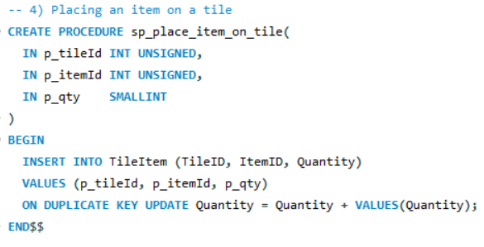

**Test Call:**

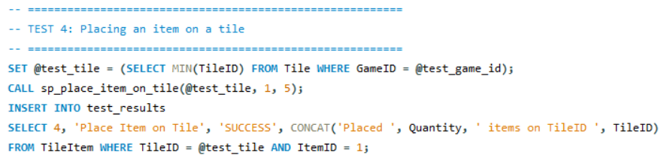

**Test Result:**



Uses INSERT … ON DUPLICATE KEY UPDATE to either create a new TileItem record or add to existing quantity if the item already exists on that tile.

### 2.6 Player Gameplay Movement

**Procedure Name:** sp_move_player

**Purpose:** Moves a player to an adjacent tile and manages turn switching.

**Parameters:**

* IN p_playerGameId INT UNSIGNED
* IN p_targetTileId INT UNSIGNED

**SQL Code:**

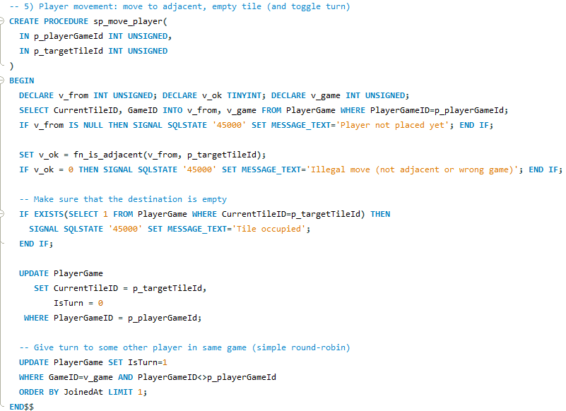

**Test Call:**

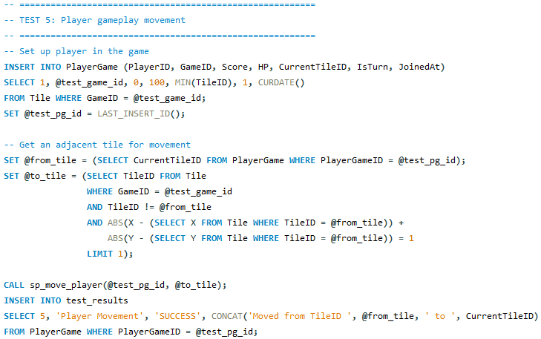

**Test Result:**



Validates that the target tile is adjacent using fn_is_adjacent function, checks the tile is empty, updates the player’s position sets their turn to 0, and gives the turn to the next player in the same game.

### 2.7 Game Play Scoring

**Procedure Name:** sp_update_score

**Purpose:** Updates a player’s score in the current game and their all-time high score.

**Parameters:**

* IN p_playerGameId INT UNSIGNED
* IN p_delta INT – Points to add (positive) or subtract (negative)

**SQL Code:**

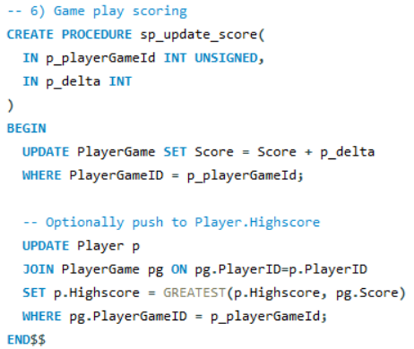

**Test Call:**

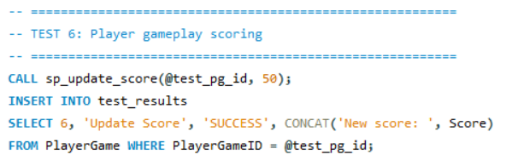

**Test Result:**



Adds the delta value to the players current game score then updates the player tables highscore if the current game score exceeds it.

### 2.8 Player Acquiring Inventory (Pickup)

**Procedure Name:** sp_pickup_item

**Purpose:** Transfers an item from a tile into a players inventory and updates score.

**Parameters:**

* IN p_playerGameId INT UNSIGNED
* IN p_itemId INT UNSIGNED
* IN p_qty SMALLINT

**SQL CODE:**

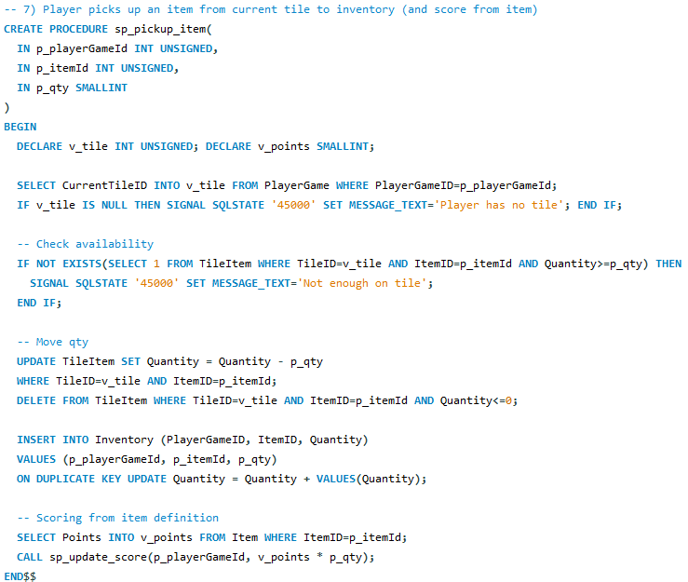

**Test Call:**

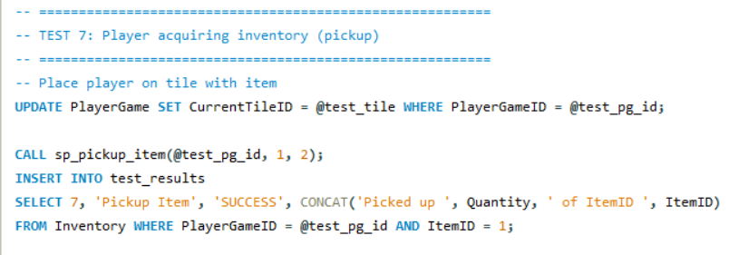

**Test Result:**



Validates that the player is on a tile, checks item availability, removes item from TileItem, adds to Inventory (or updates the quantity), and awards points based on items point value.

### 2.9 Item (NPC Effect) Movement

**Procedure Name:** sp_move_tile_item

**Purpose:** Moves an item for example roaming NPC or loot from one tile to an adjacent tile.

**Parameters:**

* IN p_tileItemId INT UNSIGNED
* IN p_targetTileId INT UNSIGNED

**SQL Code:**

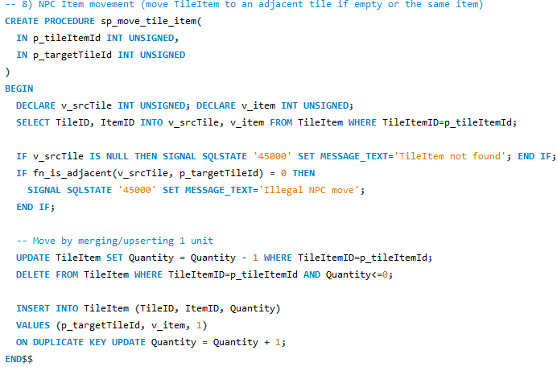

**Test Call:**

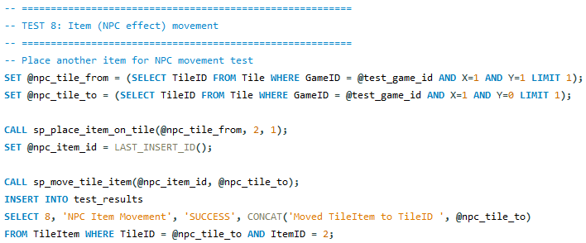

**Test Result:**



Validates adjacency, decrements quantity at source tile, deletes if empty, and inserts or adds to target tile.

### 2.10 Admin Kill Running Games

**Procedure Name:** sp_kill_game

**Purpose:** Immediately terminates an active game session.

**Parameters:**

* In p_gameId INT UNSIGNED

**SQL Code:**

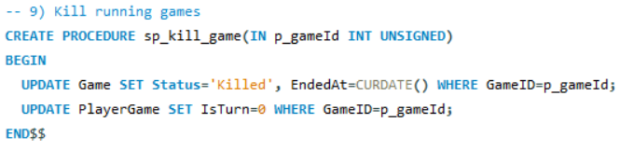

**Test Call:**

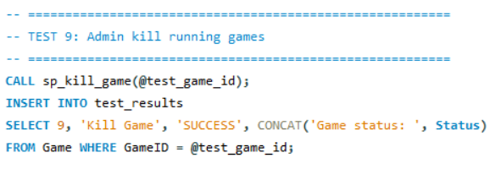

**Test Result:**



Sets game status to “Killed”, records end date, and resets all players’ turn flags to 0.

### 2.11 Admin Add New Players

**Procedure Name:** sp_admin_add_player

**Purpose:** Creates a new player account with admin privileges option.

**Parameters:**

* IN p_username VARCHAR(40)
* IN p_email VARCHAR(120)
* IN p_passwordhash CHAR(64)
* IN p_isAdmin TINYINT

**SQL Code:**

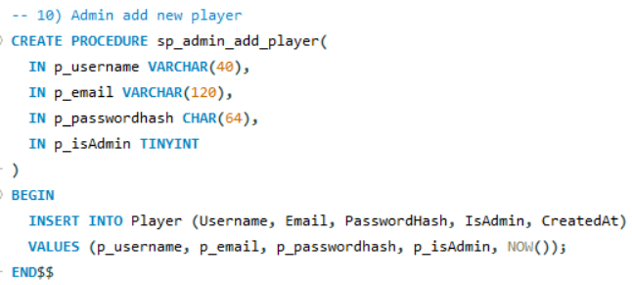

**Test Call:**

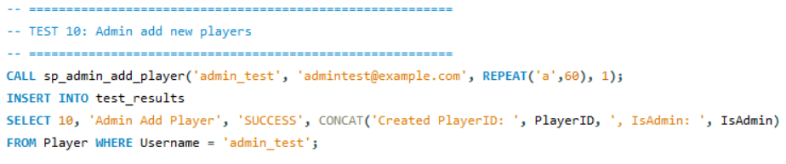

**Test Result:**



Similar to registration but allows setting admin status during creation.

### 2.12 Admin Update Player Data

**Procedure Name:** sp_admin_update_player

**Purpose:** Modifies existing player account information.

**Parameters:**

* IN p_playerId INT UNSIGNED
* IN p_username VARCHAR(40)
* IN p_email VARCHAR(120)
* IN p_passwordhash CHAR(64)
* IN p_isAdmin TINYINT
* IN p_isLocked TINYINT

**SQL Code:**

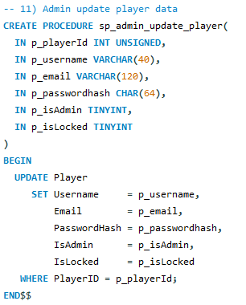

**Test Call:**

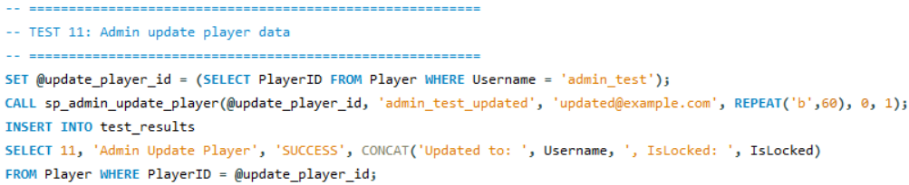

**Test Result:**



Updates all specified fields for the given player ID, allowing admin to modify credentials, admin status, and lock status.

### 2.13 Admin Delete Player

**Procedure Name:** sp_admin_delete_player

**Purpose:** Removes a player account and all associated data.

**Parameters:**

* IN p_playerId INT UNSIGNED

**SQL Code:**

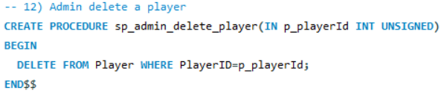

**Test Call:**

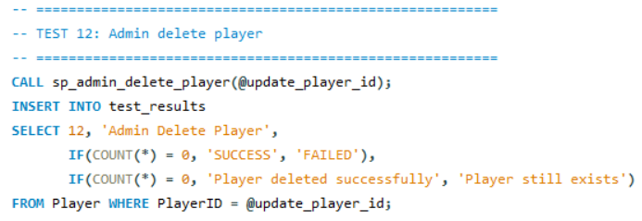

**Test Result:**



Deletes the player record. CASCADE constraints ensure cleanup of PlayerGame and Inventory records.

## 3. DAO Methods Implementation

### 3.1 Overview

All Data Access Object (DAO) classes follow a consistent pattern:

1. Open database connection using Db.GetOpenConnection()
2. Create MySqlCommand with stored procedure name
3. Set CommandType to StoredProcedure
4. Add parameters with appropriate data types
5. Execute command
6. Handle output parameters if needed
7. Connection is automatically closed through “using” statement

### 3.2 AuthDAO Class

**Location:** TheRaze.Data.AuthDao.cs

**Purpose:** Handles authentication and player account management.

#### 3.2.1 Login Method

**Implementation:**

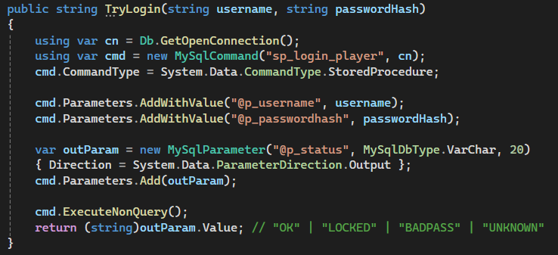

**Stored Procedure Called:** sp_login_player

Creates a connection, calls the stored procedure with username and password hash, and retrieves the output parameter @p_status which indicates login success or failure reason. Returns the status string to the calling form.

#### 3.2.2 Register Method

**Implementation:**

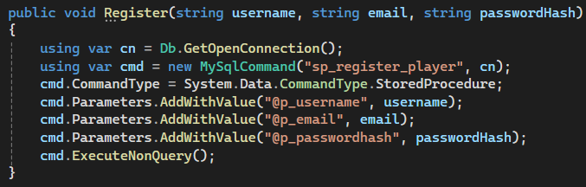

**Stored Procedure Called:** sp_register_player

Passess new player credentials to the database. Uses ExecuteNonQuery() since no return value is needed.

#### 3.2.3 Delete Own Account Method

**Implementation:**

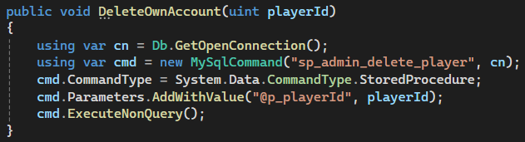

**Stored Procedure Called:** sp_admin_delete_player

Allows a player to delete their own account by passing their player ID.

### 3.3 GameDao Class

**Location:** TheRaze.Data.GameDao.cs

**Purpose:** Handles in-game actions like movement, scoring, items.

#### 3.3.1 Move Player Method

**Implementation:**

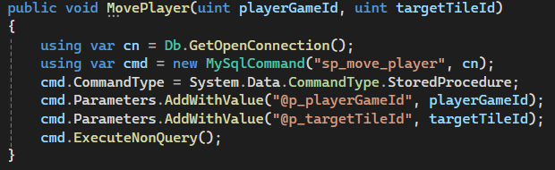

**Stored Procedure Called:** sp_move_player

Passes player game ID and target tile ID to move the player. Exceptions from invalid moves like non-adjacent or occupied are thrown by the database and caught in the GUI layer.

#### 3.3.2 Add Score Method

**Implementation:**

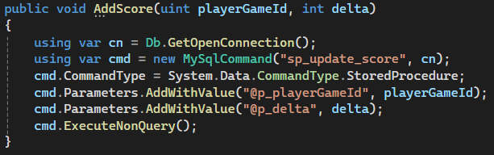

**Stored Procedure Called:** sp_update_score

Updates score by passing a positive or negative delta value.

#### 3.3.3 Pickup Item Method

**Implementation:**

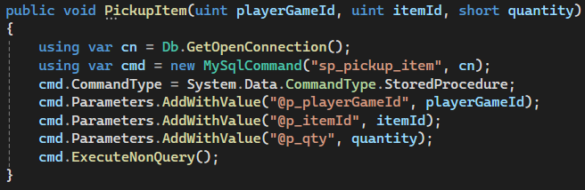

**Stored Procedure Called:** sp_pickup_item

Transfers items from tile to player inventory and updates score based on item points.

#### 3.3.4 Reset Board Method

**Implementation:**

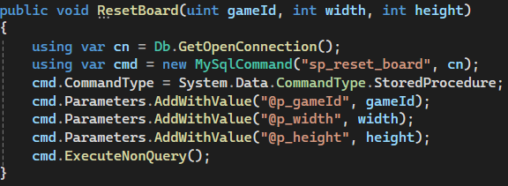

**Stored Procedure Called:** sp_reset_board

Regenerates the game board with specified dimensions.

#### 3.3.5 Place Item on Tile Method

**Implementation:**

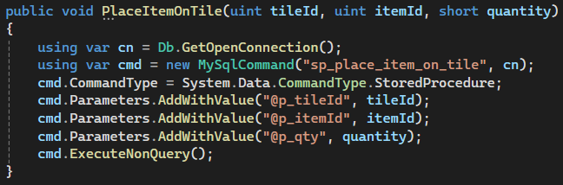

**Stored Procedure Called:** sp_place_item_on_tile

Places Items on the board for players to find.

### 3.4 AdminDao Class

**Location:** TheRaze.Data.AdminDao.cs

**Purpose:** Handles administrative functions.

#### 3.4.1 Kill Game Method

**Implementation:**

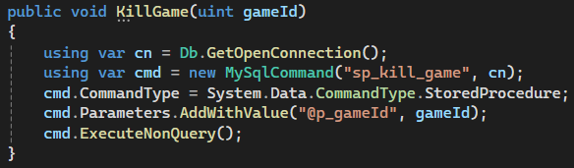

**Stored Procedure Called:** sp_kill_game

#### 3.4.2 Add Player Method

**Implementation:**

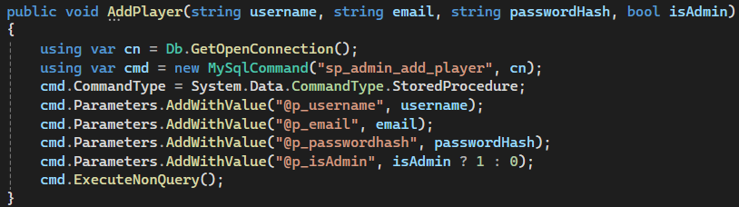

**Stored Procedure Called:** sp_admin_add_player

#### 3.4.3 Update Player Method

**Implementation:**

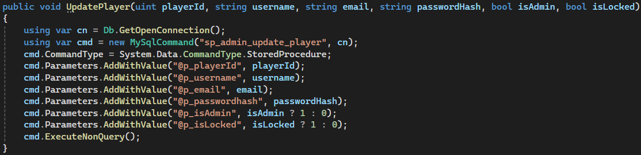

**Stored Procedure Called:** sp_admin_update_player

#### 3.4.4 Delete Player Method

**Implementation:**

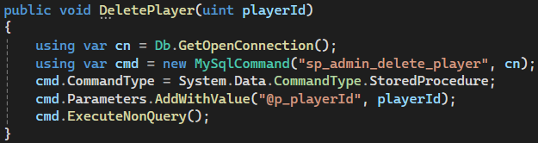

**Stored Procedure Called:** sp_admin_delete_player

## 4. GUI Components Implementation

### 4.1 LoginForm

**Location:** TheRaze.Forms.LoginForm.cs

**Purpose:** Handles user authentication and navigation to registration.

**Controls:**

* txtUsername - TextBox for username input
* txtPassword - TextBox for password input
* btnLogin - Button to trigger login
* btnRegister - Button to open registration form
* btnTestDb - Button to test database connection

#### 4.1.1 Login Button Handler

**Event Handler:**

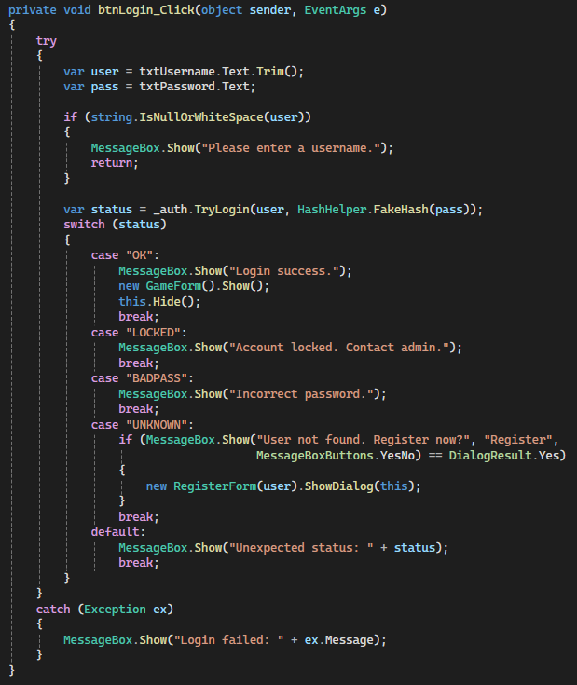

**DAO Method Called:** AuthDao.TryLogin()

**Functionality:**

* Validates username is not empty
* Hashes the password using HashHelper
* Calls DAO method to authenticate
* Handles different status responses:

**“OK”:** Opens GameForm

**“LOCKED”:** Shows lockout message

**“BADPASS”:** Shows incorrect password

**“UNKNOWN”:** Offers registration

**Successful Login:**

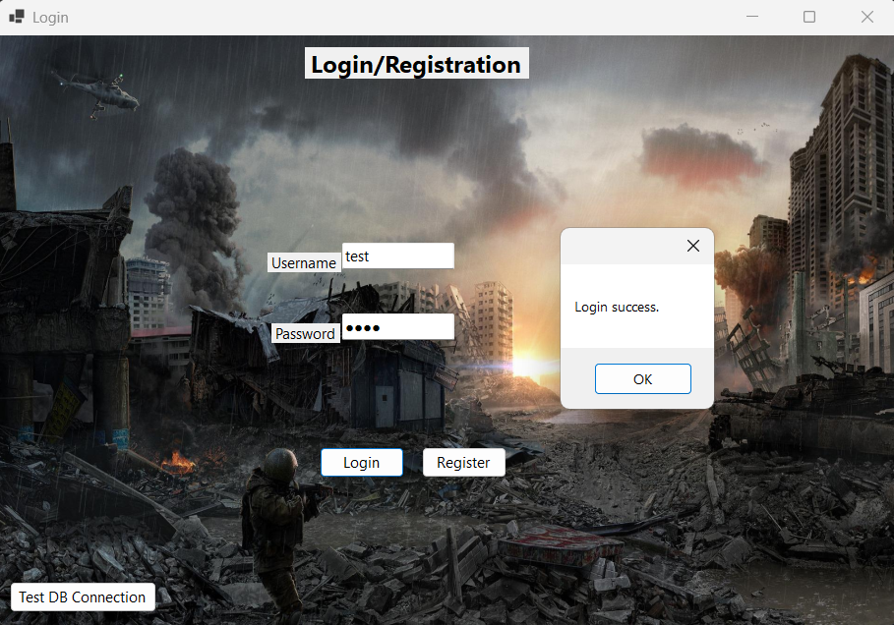

### 4.2 RegisterForm

**Location:** TheRaze.Forms.RegisterForm.cs

**Controls:**

* txtUsername – TextBox
* txtEmail – TextBox
* txtPassword – TextBox
* btnCreate - Button to submit registration
* btnCancel - Button to close form

**Registration Form:**

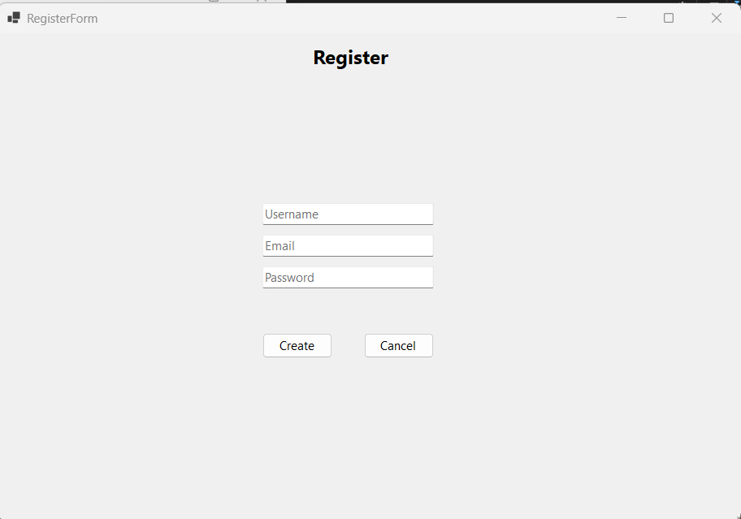

### 4.3 GameForm

**Location:** TheRaze.Forms.GameForm.cs

**Purpose:** Main gameplay interface for player actions and game management.

#### 4.3.1 Move Player

**Controls:**

* txtPlayerGameId – TextBox
* txtTargetTileId – TextBox
* btnMove – Button

**Event Handler:**

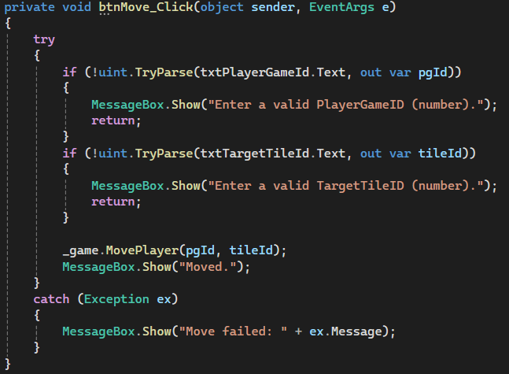

**DAO Method:** GameDao.MovePlayer()

#### 4.3.2 Add Score

**Controls:**

* txtPlayerGameId – TextBox (shared)
* txtDelta – textbox
* btnAddScore – Button

**Event Handler:**

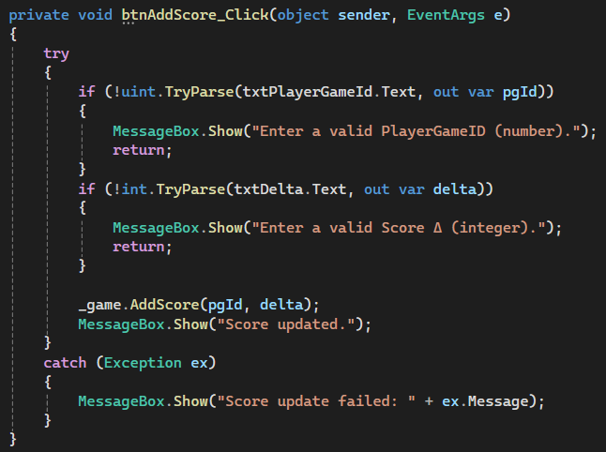

**DAO Method:** GameDao.AddScore()

#### 4.3.3 Pickup Item

**Controls:**

* txtPlayerGameId - TextBox (shared)
* txtItemId – TextBox
* txtQuantity – TextBox
* btnPickup - Button

**Event Handler:**

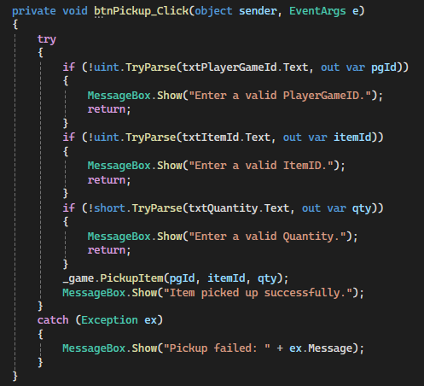

**DAO Method:** GameDao.PickupItem()

#### 4.3.4 Reset Board

**Controls:**

* txtResetGameId – TextBox
* txtWidth – TextBox
* txtHeight – TextBox
* btnResetBoard – Button

**Event Handler:**

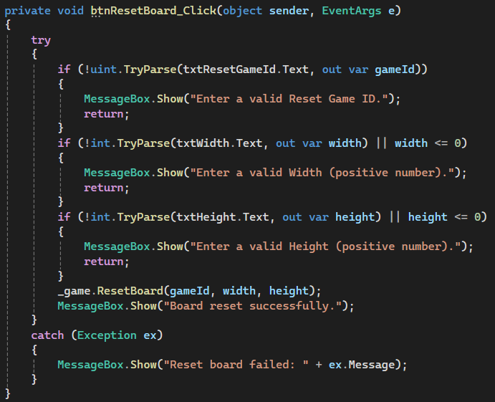

**DAO Method:** GameDao.ResetBoard()

#### 4.3.5 Place Item

**Controls:**

* txtPlaceTileId – TextBox
* txtPlaceItemId – TextBox
* txtPlaceQty – TextBox
* btnPlaceItem – Button

**Event Handler:**

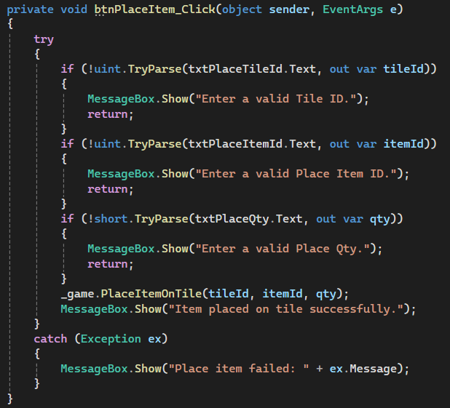

**DAO Method:** GameDao.PlaceItemOnTile()

#### 4.3.6 Delete Account

**Controls:**

* txtPlayerIdToDelete – TextBox
* btnDeleteAccount – Button

**Event Handler:**

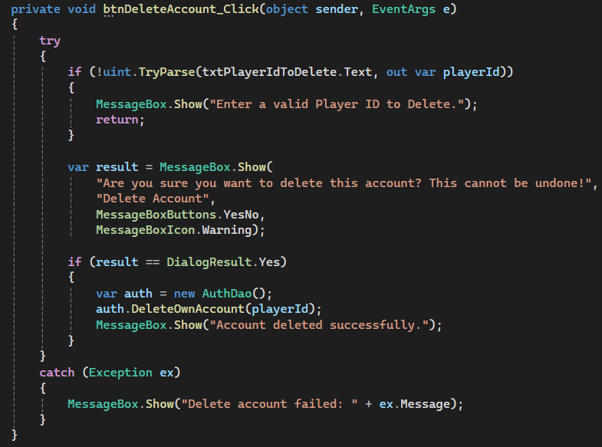

**DAO Method:** AuthDao.DeleteOwnAccount()

### 4.4 AdminForm

**Location:** TheRaze.Forms.AdminForm.cs

**Purpose:** Administrative controls for managing games and players.

#### 4.4.1 Kill Game

**Controls:**

* txtGameId - TextBox
* btnKill – Button

**Code Snippet:**

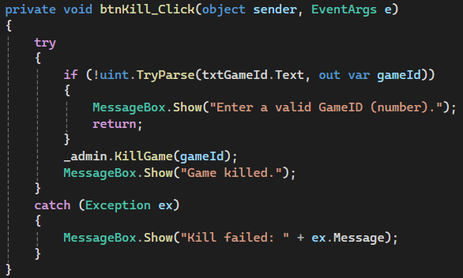

**User Interface Screenshot:**

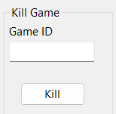

#### 4.4.2 Add Player

**Controls:**

* txtU - TextBox (username)
* txtE - TextBox (email)
* txtP - TextBox (password)
* chkAdmin – CheckBox
* btnAdd – Button

**Code Snippet:**

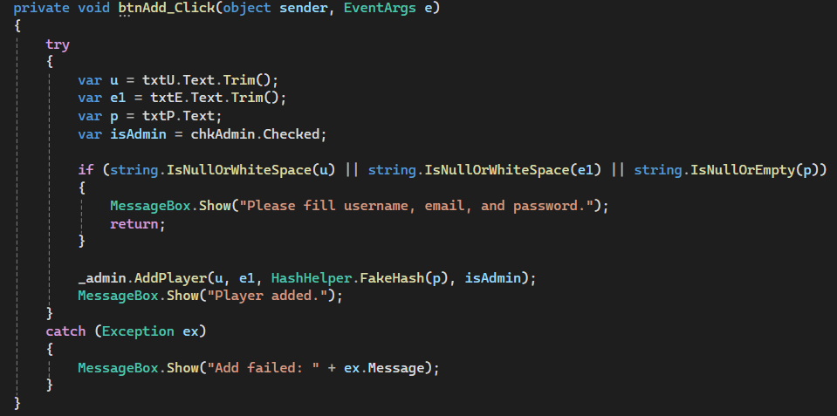

**User Interface Screenshot:**

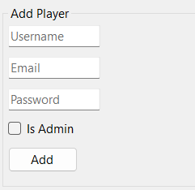

#### 4.4.3 Update Player

**Controls:**

* txtPlayerId – TextBox
* txtU2, txtE2, txtP2 – TextBoxes
* chkAdmin2, chkLocked2 – CheckBoxes
* btnUpdate – Button

**Code Snippet:**

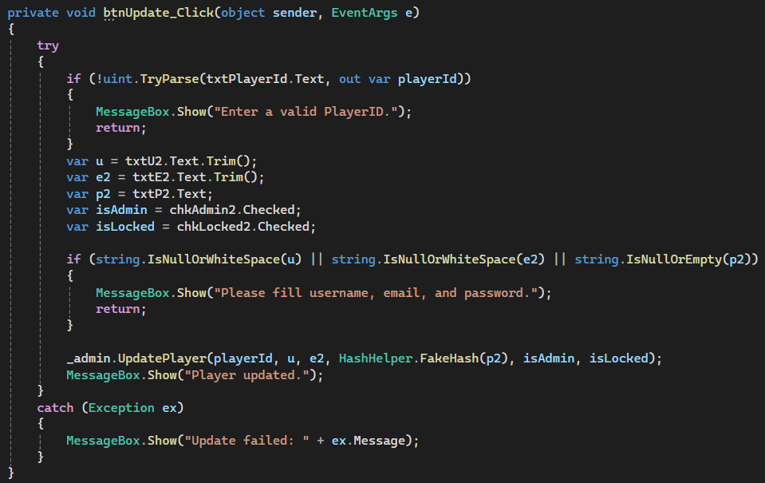

**User Interface Screenshot:**

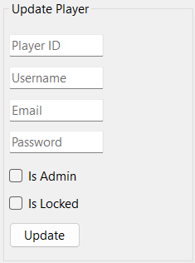

#### 4.4.4 Delete Player

**Controls:**

* txtPlayerIdDel – TextBox
* btnDelete – Button

**Code Snippet:**

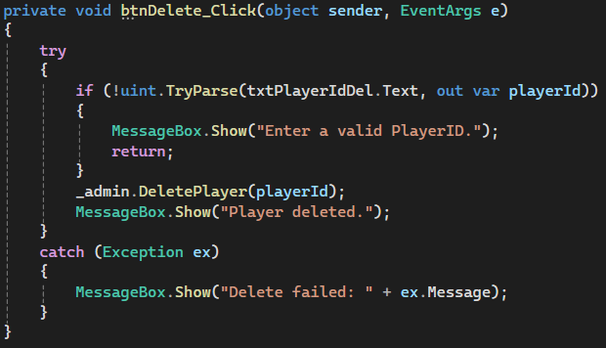

**User Interface Screenshot:**

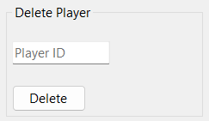

## 5. Testing Evidence

### 5.1 Comprehensive Test Script

A complete SQL test script was created to verify all 12 processes work correctly. The script tests each procedure with valid inputs and records results.

The script is included in the DAT602-Assessment-Two-M2-SQL-Script file.

**Summary:**

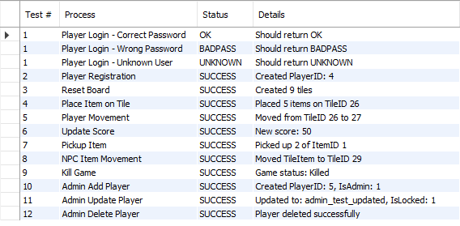

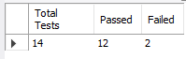

### 5.2 GUI Testing

Each GUI component was manually tested through the Windows Forms interface. All 12 processes were successfully executed with appropriate success messages displayed. For testing purposes and time constraints, players were manually placed to check if the game recognizes if a player is in the game or not. Plans were made to include the “Join Game” feature and ensure that there is a proper game flow such as:

1. Player registration/logging in
2. Player joins/creates a game lobby
3. Game starts

**Error Handling:** Error handling was implemented using try-catch blocks. Examples of error messages:

* "Player has no tile" when attempting pickup without being placed
* "Tile occupied" when trying to move to a non-empty tile
* Foreign key constraint errors when using invalid IDs

# Assignment 2 Milestone Three

## 1. TSQL Concurrency and transactions and C# Code Refactoring

##### Process 1: Player Login (Including Lockout)

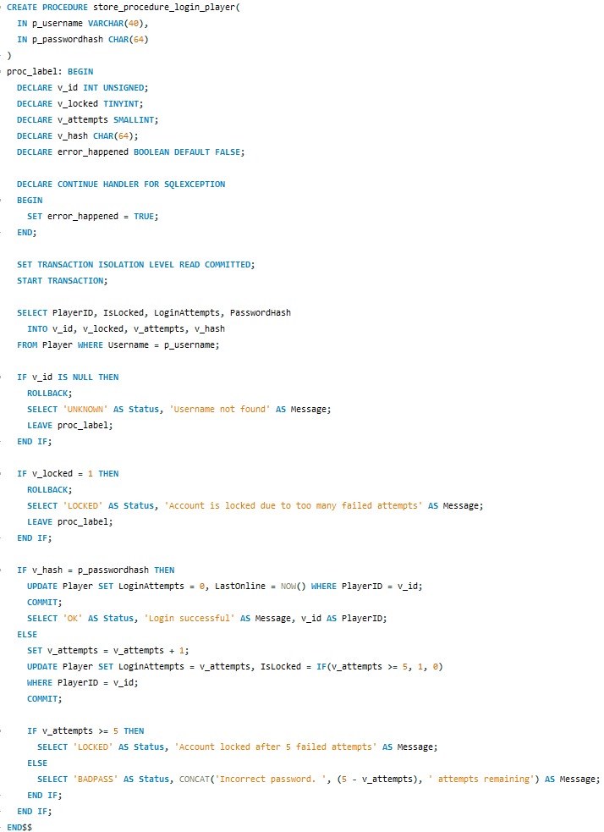

**Transaction Management:** This procedure uses READ COMMITTED isolation level which is appropriate for login operations as it prevents dirty reads while allowing good concurrency. The procedure begins with START TRANSACTION and either commits on success or rolls back on any error condition.

**Error Handling:** A DECLARE CONTINUE HANDLER FOR SQLEXCEPTION is implemented to catch any database errors. The error_happened flag is set to TRUE if an exception occurs, triggering a ROLLBACK and error message.

**Validation Logic:** The procedure performs three validation checks:

1. Verifies the username exists in the database
2. Checks if the account is locked (IsLocked = 1)
3. Compares the provided password hash with the stored hash

**Lockout Mechanism:** Failed login attempts increment the LoginAttempts counter. After 5 failed attempts, the IsLocked flag is set to 1 preventing further login attempts. The procedure uses a label (proc_label:) and LEAVE statement for early exit on validation failures.

**Result Set:** Returns a SELECT statement with Status (“OK”, “LOCKED”, “BADPASS”, “UNKNOWN”, “ERROR”), Message (descriptive text), and PlayerID (only when Status = 'OK').

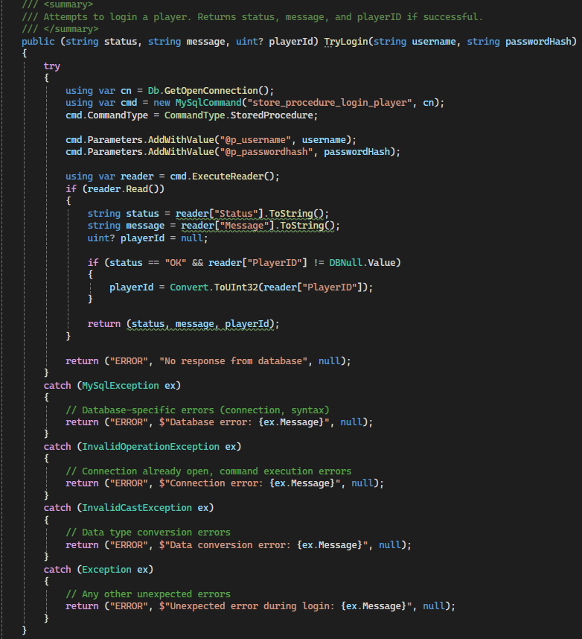

**How Stored Procedure Data is Used:** The stored procedure store_procedure_login_player returns a SELECT result set containing Status, Message, and PlayerID columns. The DAO method uses ExecuteReader() to retrieve these results.

The method processes the Status column to determine the login outcome:

* **“OK”**: Successful login - extracts PlayerID and returns it
* **“LOCKED”**: Account locked - returns error message from procedure
* **“BADPASS”**: Incorrect password - returns remaining attempts message
* **“UNKNOWN”**: Username not found - returns error message
* **“ERROR”**: Database error - returns error details

All three values (status, message, playerId) are returned as a tuple to the GUI layer for processing.

**Exception Handling:** The method implements multiple catch blocks:

* MySqlException: Catches database-specific errors (connection failures, query syntax errors)
* InvalidOperationException: Catches connection state errors
* InvalidCastException: Catches data type conversion errors
* Exception: Catch-all for unexpected errors

Each exception returns a tuple with “ERROR” status and a descriptive error message allowing the GUI to display appropriate feedback to the user.

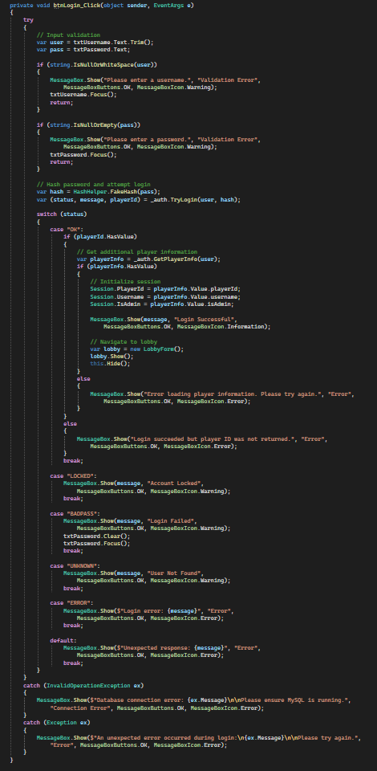

**GUI Layer Error Handling:** The GUI implements a try-catch block that wraps all login operations. Before calling the DAO, input validation ensures username and password fields are not empty, providing immediate feedback without unnecessary database calls.

The method uses a switch statement to handle each possible status code from the DAO:

* **“OK”**: Initializes the session with player data and navigates to the lobby
* **“LOCKED”**: Displays account locked warning
* **“BADPASS”**: Displays password error and clears password field for retry
* **“UNKNOWN”**: Displays username not found error
* **“ERROR”**: Displays database error message

**Exception Handling:** Two specific catch blocks handle different error scenarios:

* InvalidOperationException: Displays database connection error with guidance to check if MySQL is running
* Exception: Displays a generic error message for unexpected issues

This layered error handling approach ensures users receive clear, actionable error messages at each stage of the login process.

###### Test Results:

Test 1: Successful Login

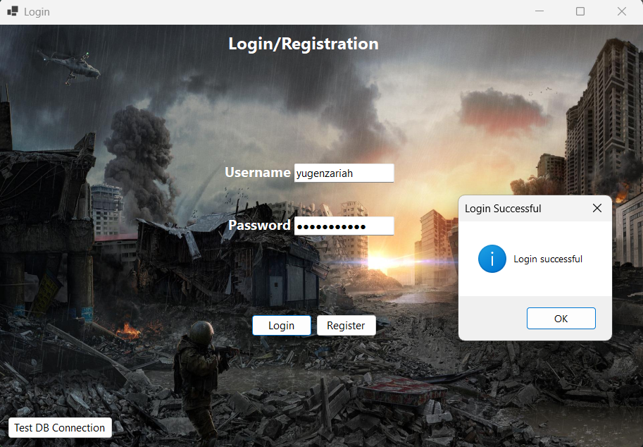

Succesful Login with valid credentials (yugenzariah/password123).

Test 2: Invalid Username

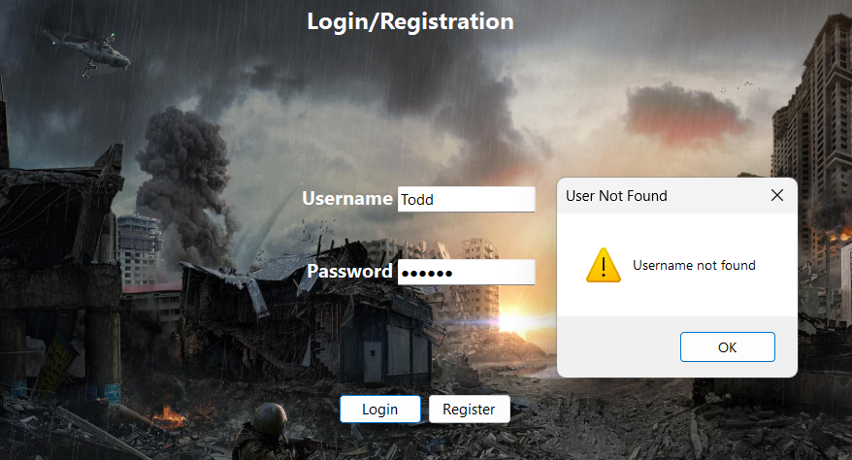

Error handling for non-existent username.

Test 3: Wrong Password with Attempts Remaining

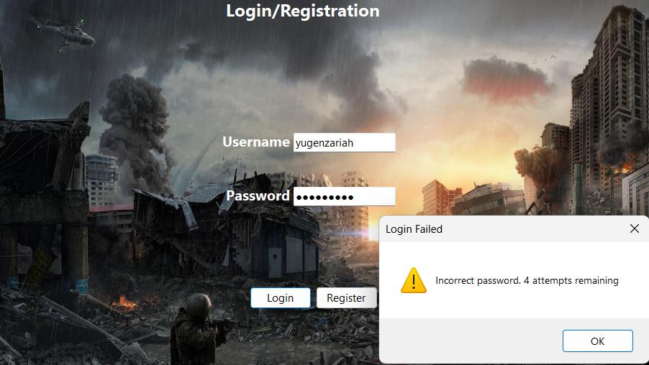

Failed login attempt showing remaining attempts.

Test 4: Account Lockout

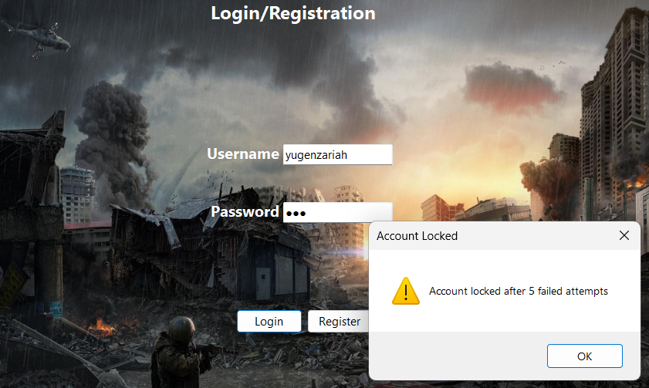

Account locked after 5 failed attempts and the user needs to contact an admin to unlock account.

##### Process 2: Player Registration

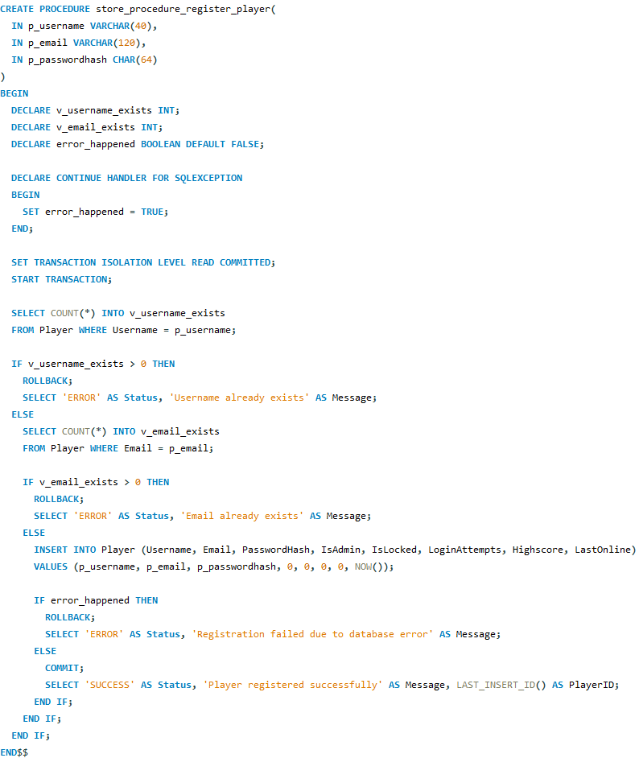

**Transaction Management:** Uses READ COMMITTED isolation level for registration operations. The transaction ensures that username and email uniqueness checks and the INSERT operation either all succeed or all fail atomically.

**Error Handling:** Implements DECLARE CONTINUE HANDLER FOR SQLEXCEPTION to catch database errors. The procedure checks for duplicate usernames and emails BEFORE attempting the INSERT preventing constraint violation errors and providing meaningful error messages.

**Validation Logic:** Two validation checks are performed within the transaction:

1. Checks if username already exists (SELECT COUNT into v_username_exists)
2. Checks if email already exists (SELECT COUNT into v_email_exists)

Only if both checks pass does the procedure proceed with the INSERT operation. This prevents the database from throwing a UNIQUE constraint violation and allows the application to provide specific feedback about which field is duplicated.

**Result Set:** Returns Status (“SUCCESS” or “ERROR”), Message (specific error or success message), and PlayerID (LAST_INSERT_ID() when registration succeeds).

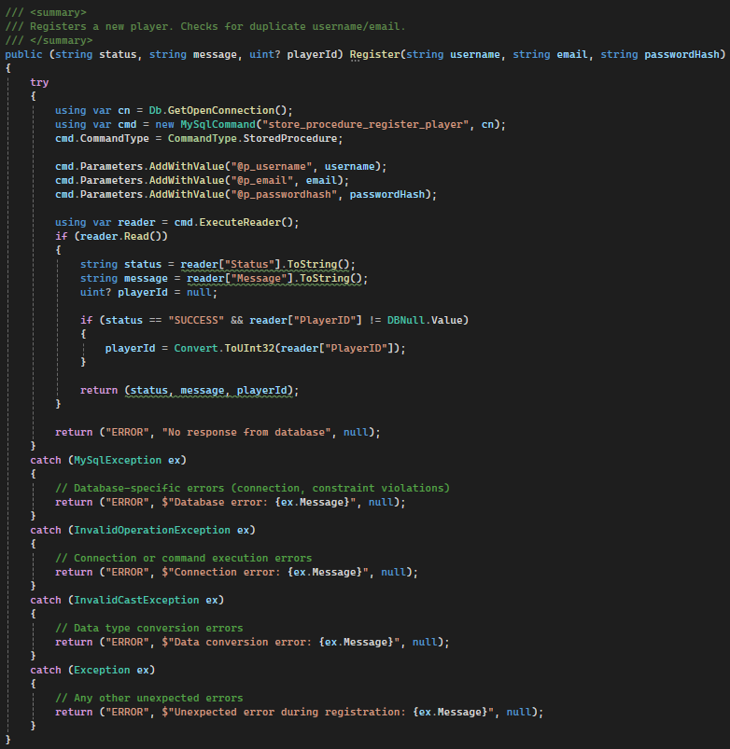

**How Stored Procedure Data is Used:** The stored procedure returns a result set with Status, Message, and PlayerID columns. The DAO extracts these values using ExecuteReader():

* **Status = “SUCCESS”**: Registration successful, PlayerID contains the new player's ID
* **Status = “ERROR”**: Registration failed, Message contains the specific reason (username exists, email exists, or database error)

The tuple return type (string status, string message, uint? playerId) allows the GUI to handle success and various error conditions differently.

**Exception Handling:** Multiple catch blocks handle different error types:

* MySqlException: Database-specific errors (connection issues, constraint violations that bypass stored procedure checks)
* InvalidOperationException: Connection or command execution errors
* InvalidCastException: Data type conversion errors when reading PlayerID
* Exception: Catch-all for unexpected errors

All exceptions return descriptive error tuples that the GUI can display to users.

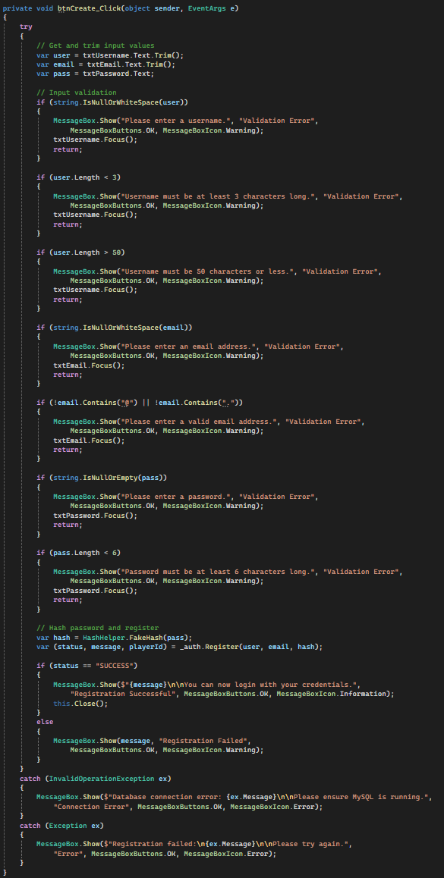

**GUI Layer Error Handling:** The registration form implements comprehensive client-side validation before calling the DAO:

* Checks all fields are filled
* Validates username length (minimum 3 characters, maximum 50)
* Validates email format (contains “@” and “.”)
* Validates password length (minimum 6 characters)

This validation reduces unnecessary database calls and provides immediate feedback. After validation passes, the method calls the DAO and handles the result:

* **Status = “SUCCESS”**: Displays success message and closes form
* **Status = “ERROR”**: Displays the specific error message from the stored procedure

**Exception Handling:** Two catch blocks handle errors:

* InvalidOperationException: Database connection errors with guidance
* Exception: Generic error handling for unexpected issues

This layered approach (client validation to DAO validation to database validation) ensures robust error handling at every level.

###### Test Results:

Test 1: Successful Registration

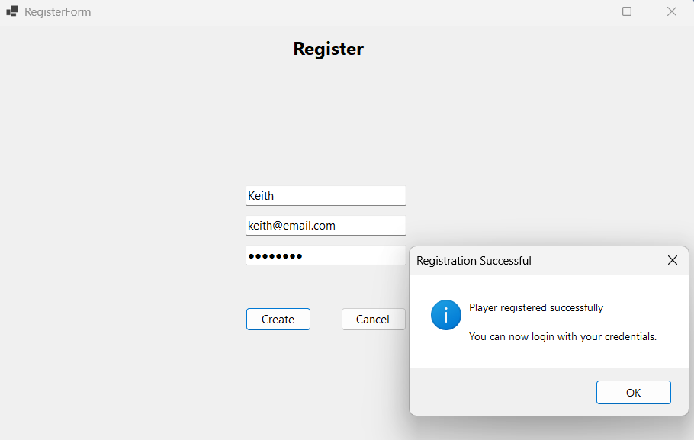

Test 2: Duplicate Username

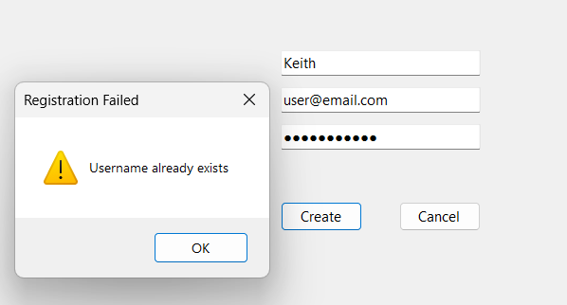

Test 3: Duplicate Email

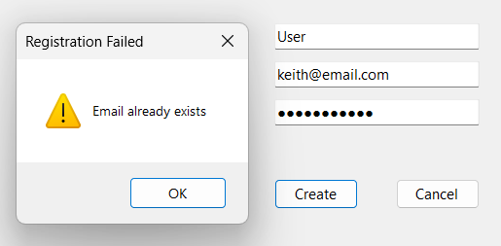

Test 4: Empty Fields

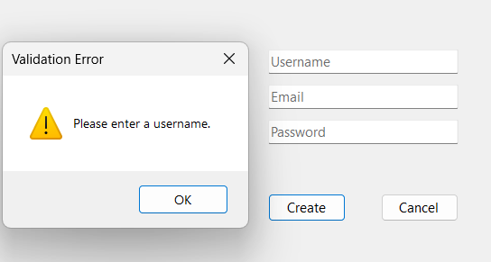

Test 5: Invalid Email Format

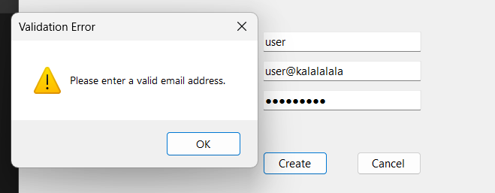

##### Process 3: Reset Board/Laying Out Tiles

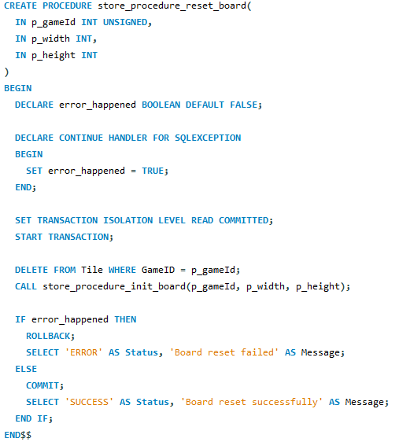

**Transaction Management:** Uses READ COMMITTED isolation level. The transaction ensures that deleting old tiles and creating new tiles happens atomically - either both operations succeed or both are rolled back.

**Error Handling:** Implements DECLARE CONTINUE HANDLER FOR SQLEXCEPTION to catch any errors during the DELETE or board initialization. If an error occurs, the transaction is rolled back, leaving the board in its previous state.

**Operations:** The procedure performs two main operations:

1. **DELETE FROM Tile WHERE GameID = p_gameId** - Removes all existing tiles (cascade deletes related TileItem records due to foreign key constraints)
2. **CALL store_procedure_init_board** - Creates new tiles in a nested loop based on width and height parameters

**Atomic Execution:** Because both operations are within the same transaction, the board cannot end up in a partial state. If init_board fails, the delete is rolled back, preserving the original board.

**Result Set:** Returns Status (“SUCCESS” or “ERROR”) and Message describing the outcome.

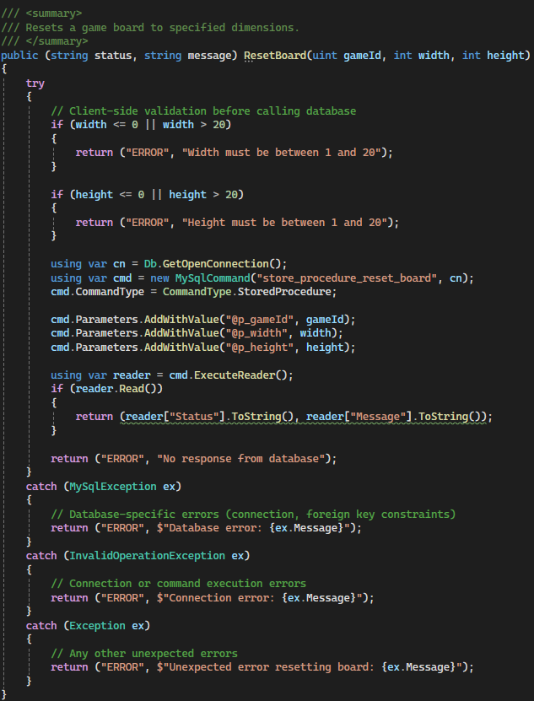

**How Stored Procedure Data is Used:** The procedure returns Status and Message columns. The DAO reads these using ExecuteReader() and returns them as a tuple for the GUI to process.

**Client-Side Validation:** Before calling the stored procedure, the DAO validates:

* Width is between 1 and 20
* Height is between 1 and 20

This prevents invalid parameters from reaching the database and provides immediate feedback.

**Exception Handling:** Three catch blocks handle different scenarios:

* MySqlException: Database errors (connection, foreign key constraints)
* InvalidOperationException: Connection or command execution errors
* Exception: Unexpected errors

All exceptions return error tuples with descriptive messages.

##### Process 4: Place Item on Tile

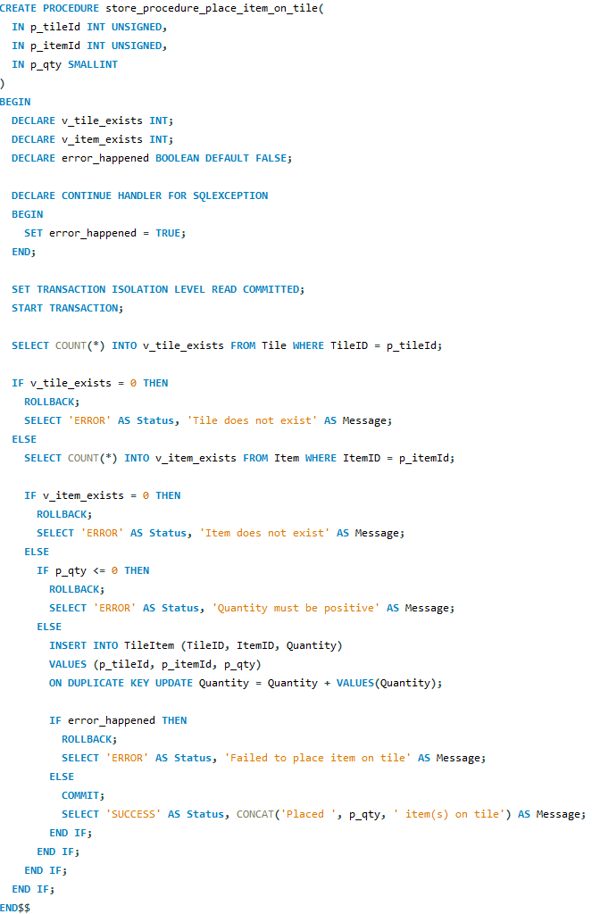

**Transaction Management:** Uses READ COMMITTED isolation level. The transaction ensures the validation checks and UPSERT operation execute atomically.

**Error Handling:** Implements DECLARE CONTINUE HANDLER FOR SQLEXCEPTION with error_happened flag to catch and handle database errors.

**Validation Logic:** Three validation checks before the UPSERT:

1. Verifies the tile exists (v_tile_exists)
2. Verifies the item exists (v_item_exists)
3. Checks quantity is positive (p_qty > 0)

**UPSERT Operation:** The INSERT...ON DUPLICATE KEY UPDATE statement handles two scenarios:

* If the item doesn't exist on the tile: INSERT new record
* If the item already exists on the tile: UPDATE quantity by adding the new amount

This is a classic UPSERT (Update or Insert) operation that prevents duplicate (TileID, ItemID) records while accumulating quantities.

**Result Set:** Returns Status (“SUCCESS” or “ERROR”) and Message (specific error or confirmation like "Placed X item(s) on tile").

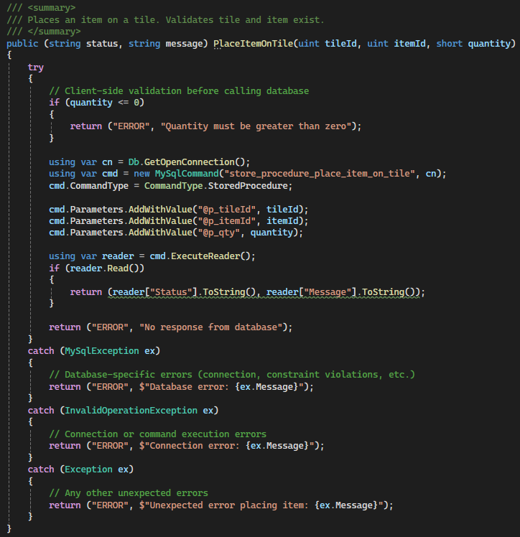

**How Stored Procedure Data is Used:**

The stored procedure store_procedure_place_item_on_tile returns a SELECT result set containing Status and Message columns. The DAO method uses ExecuteReader() to retrieve these results and returns them as a tuple.

**Client-Side Validation:**

Before calling the stored procedure, the DAO performs validation:

* Checks that quantity is greater than zero

This provides immediate feedback without a database round-trip for obviously invalid input.

**Exception Handling:**

Three catch blocks handle different scenarios:

* MySqlException: Database-specific errors (connection issues, foreign key violations)
* InvalidOperationException: Connection or command execution errors
* Exception: Catch-all for unexpected errors

Each exception returns a tuple with 'ERROR' status and descriptive message.

##### Process 5: Player Movement

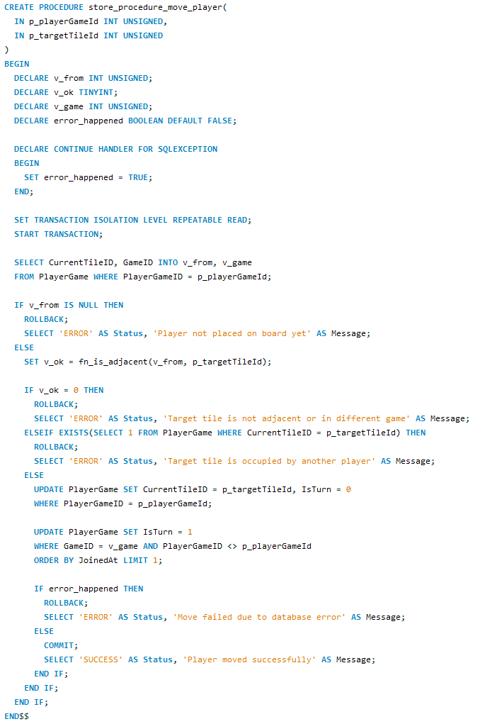

**Transaction Management:** Uses REPEATABLE READ isolation level. This prevents other transactions from modifying the tiles being read during the move operation, ensuring the adjacency check and occupancy check remain consistent throughout the transaction.

**Error Handling:** Implements DECLARE CONTINUE HANDLER FOR SQLEXCEPTION with error_happened flag to catch database errors.

**Validation Logic:** Three checks before allowing movement:

1. Player has a current tile (CurrentTileID is not null)
2. Target tile is adjacent to current tile using the fn_is_adjacent function
3. Target tile is not occupied by another player (no other PlayerGame has that CurrentTileID)

**Turn Management:** After successful move, the procedure:

1. Updates the player's CurrentTileID to the new position
2. Sets the player's IsTurn flag to 0 (ending their turn)
3. Gives the turn to the next player in the game by setting their IsTurn to 1 (ORDER BY JoinedAt LIMIT 1)

**Result Set:** Returns Status (“SUCCESS” or “ERROR”) and Message describing the outcome or specific error.

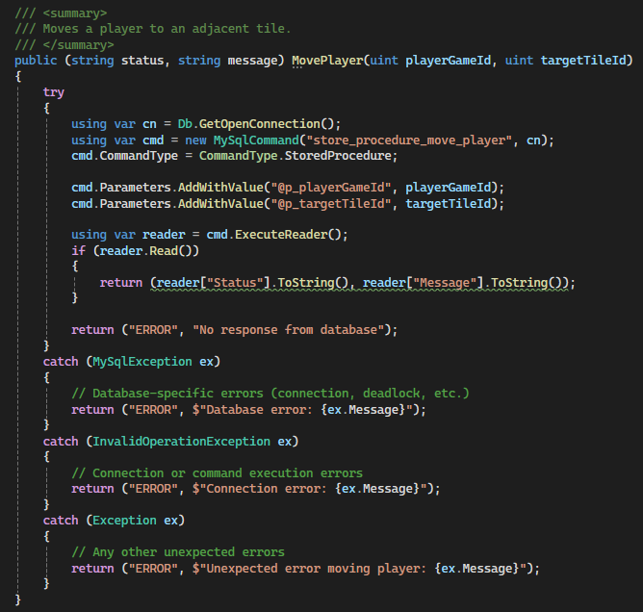

**How Stored Procedure Data is Used:**

The stored procedure store_procedure_move_player returns a result set with Status and Message columns. The DAO extracts these values using ExecuteReader():

* **Status = “SUCCESS”**: Player moved successfully
* **Status = “ERROR”**: Movement failed with specific reason (not adjacent, tile occupied, player not placed)

The tuple return allows the GUI to provide appropriate feedback.

**Exception Handling:**

Three catch blocks:

* MySqlException: Database errors (connection issues, deadlock scenarios)
* InvalidOperationException: Connection or command execution errors
* Exception: Unexpected errors

All exceptions return error tuples for the GUI to display.

##### Process 6: Update Score

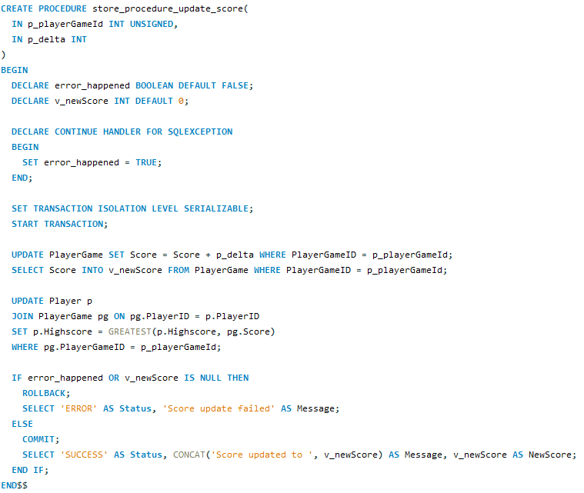

**Transaction Management:** Uses SERIALIZABLE isolation level which is the strictest isolation level. This prevents all concurrency anomalies and ensures that concurrent score updates don't result in lost updates. If two players pick up items simultaneously, both score changes are applied correctly without one overwriting the other.

**Operations:** Three operations within a single transaction:

1. Updates PlayerGame.Score by adding the delta value
2. Retrieves the new score value to return to the application
3. Updates Player.Highscore if the new score exceeds the player's previous high score (using GREATEST function)

**Error Handling:** Implements DECLARE CONTINUE HANDLER FOR SQLEXCEPTION with error_happened flag. Checks if error occurred or if the retrieved score is NULL before committing.

**Result Set:** Returns Status (“SUCCESS” or “ERROR”), Message (describing outcome), and NewScore (the updated score value when successful).

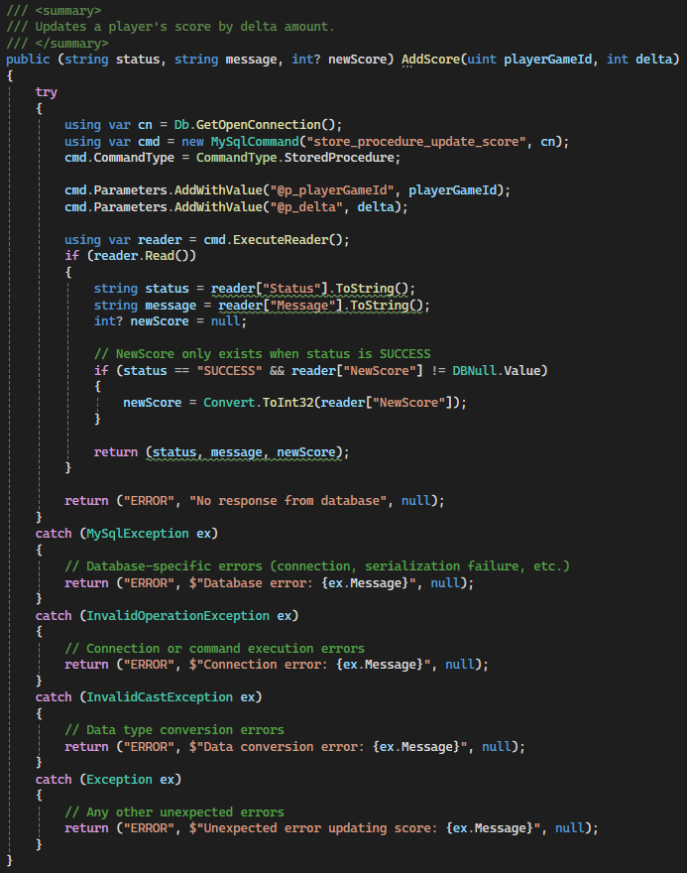

The stored procedure store_procedure_update_score returns a result set with Status, Message, and NewScore columns. The DAO extracts these values using ExecuteReader():

* **Status = “SUCCESS”**: Score updated, NewScore contains the updated value
* **Status = “ERROR”**: Update failed, Message contains error details

The tuple return type (string status, string message, int? newScore) allows the GUI to immediately display the updated score.

**Exception Handling:**

Four catch blocks handle different scenarios:

* MySqlException: Database-specific errors (connection issues, serialization failures)
* InvalidOperationException: Connection or command execution errors
* InvalidCastException: Data type conversion errors when reading NewScore
* Exception: Catch-all for unexpected errors

All exceptions return error tuples with null for newScore.

##### Process 7: Pickup Item

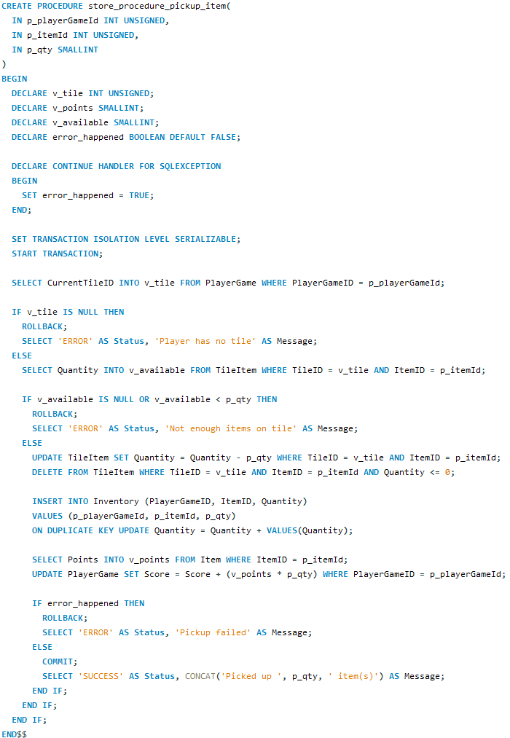

**Transaction Management:** Uses SERIALIZABLE isolation level to prevent race conditions where multiple players might try to pick up the same item simultaneously. This ensures that item quantities are decremented correctly and no duplication occurs.

**Complex Multi-Step Operation:** The procedure performs multiple operations within a single transaction:

1. Retrieves the player's current tile location from PlayerGame
2. Verifies the player is on a tile (CurrentTileID is not null)
3. Checks if the specified item exists on that tile with sufficient quantity
4. Decrements the item quantity from TileItem (deletes the record if quantity reaches 0)
5. Adds the item to the player's Inventory using UPSERT (INSERT...ON DUPLICATE KEY UPDATE)
6. Retrieves the item's point value from the Item table
7. Updates the player's score by adding (points and quantity)

**UPSERT in Inventory:** The INSERT...ON DUPLICATE KEY UPDATE ensures that if the player already has the item, the quantity is increased rather than creating a duplicate inventory record.

**Result Set:** Returns Status (“SUCCESS” or “ERROR”) and Message describing the outcome.

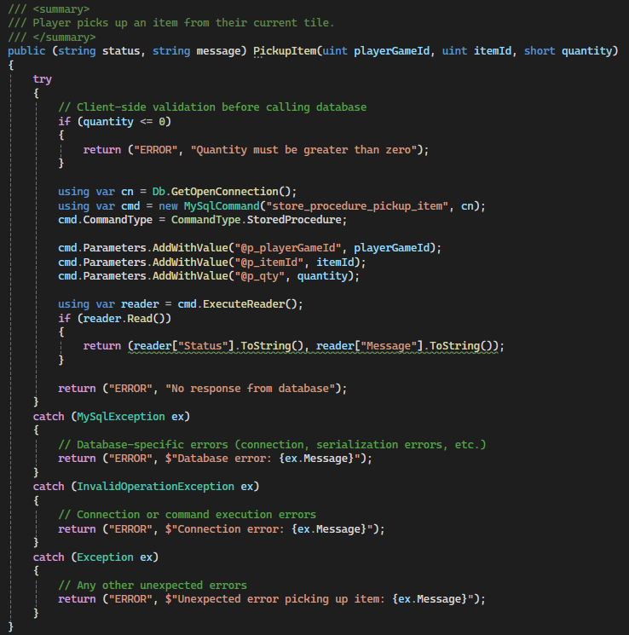

**How Stored Procedure Data is Used:**

The stored procedure store_procedure_pickup_item returns a result set with Status and Message columns. The DAO extracts these using ExecuteReader():

* **Status = “SUCCESS”**: Item picked up successfully, score automatically updated
* **Status = “ERROR”**: Pickup failed with specific reason (no tile, not enough items, etc.)

**Client-Side Validation:**

Before calling the stored procedure, the DAO validates:

* Quantity is greater than zero

This provides immediate feedback for invalid input.

**Exception Handling:**

Three catch blocks:

* MySqlException: Database errors (connection issues, serialization errors)
* InvalidOperationException: Connection or command execution errors
* Exception: Unexpected errors

All exceptions return error tuples with descriptive messages.

##### Process 8: Move Tile Item (NPC Movement)

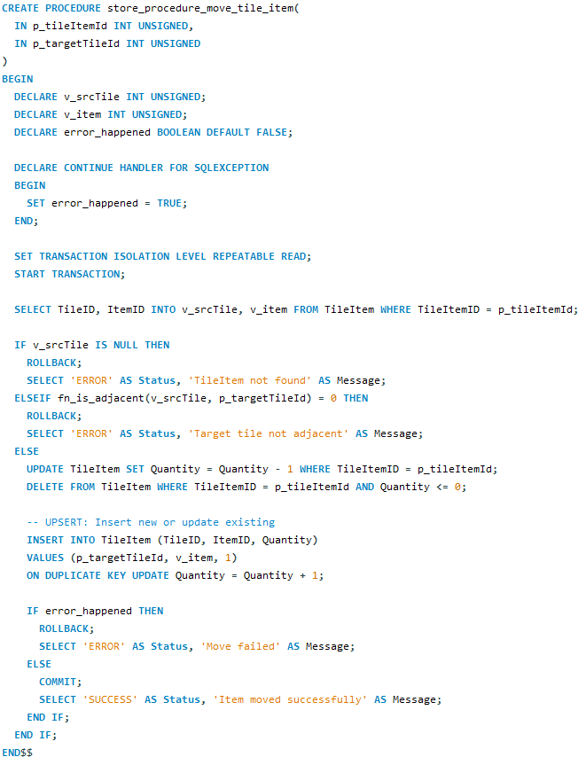

**Transaction Management:** Uses REPEATABLE READ isolation level to ensure consistent reads during the movement operation.

**Error Handling:** Implements DECLARE CONTINUE HANDLER FOR SQLEXCEPTION with error_happened flag.

**Validation Logic:** Two validation checks:

1. Verifies the TileItem exists (retrieves source tile and item ID)
2. Checks that target tile is adjacent to source tile using fn_is_adjacent function

**UPSERT Operation - Key Feature:** The procedure uses INSERT...ON DUPLICATE KEY UPDATE for the target tile:

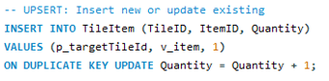

This UPSERT ensures:

* **If item doesn't exist on target tile**: INSERT creates new record with quantity 1
* **If item already exists on target tile**: UPDATE increases quantity by 1

This is critical for NPC movement because items of the same type should combine when moving to a tile that already has that item, rather than creating duplicate entries which would violate the UNIQUE constraint on (TileID, ItemID).

**Result Set:** Returns Status (“SUCCESS” or “ERROR”) and Message describing the outcome.

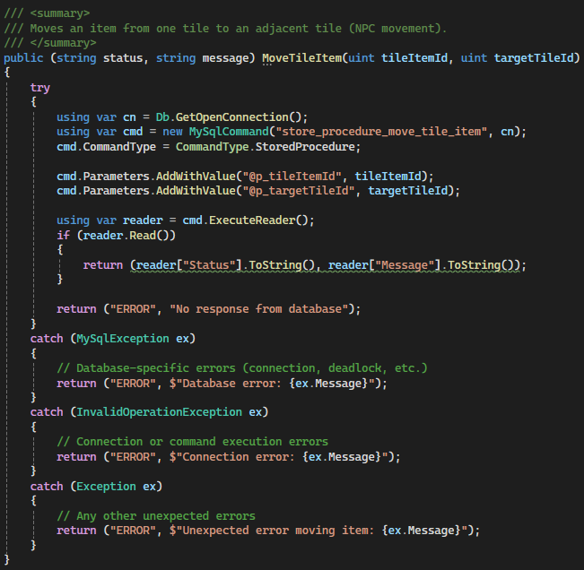

**How Stored Procedure Data is Used:**

The stored procedure store_procedure_move_tile_item returns a result set with Status and Message columns. The DAO extracts these using ExecuteReader():

* **Status = 'SUCCESS'**: Item moved successfully to adjacent tile
* **Status = 'ERROR'**: Movement failed (tile item not found, target not adjacent)

The DAO is typically called by the NPC timer in the GameForm, which moves random items every 15 seconds to create dynamic gameplay.

**Exception Handling:**

Three catch blocks:

* MySqlException: Database errors (connection issues, deadlock scenarios)
* InvalidOperationException: Connection or command execution errors
* Exception: Unexpected errors

All exceptions return error tuples. Since this is an NPC operation, errors are typically logged rather than displayed to users.

##### Process 9: Kill Game

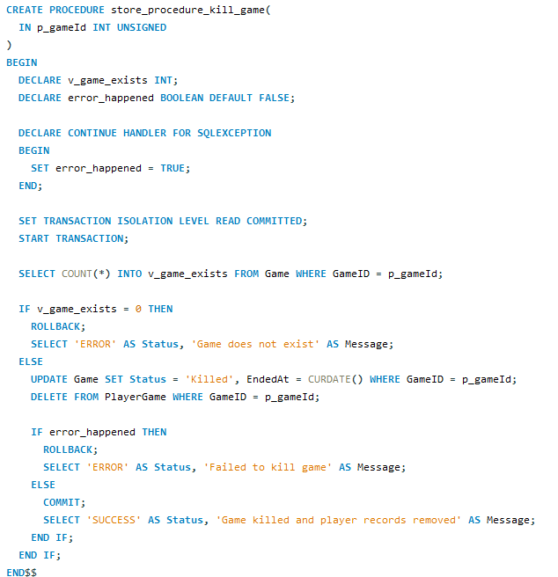

**Transaction Management:** Uses READ COMMITTED isolation level. This is appropriate for administrative operations that don't require stricter isolation.

**Error Handling:** Implements DECLARE CONTINUE HANDLER FOR SQLEXCEPTION with error_happened flag.

**Validation Logic:** Before killing the game, checks if the game exists (SELECT COUNT into v_game_exists).

**Operations:** Two operations within the transaction:

1. **UPDATE Game SET Status = “Killed”, EndedAt = CURDATE()** - Marks the game as killed with end date
2. **DELETE FROM PlayerGame WHERE GameID = p_gameId** - Removes all player records from the game

**Cascade Effects:** Deleting PlayerGame records cascades to Inventory records due to foreign key constraints with ON DELETE CASCADE. This properly cleans up all game-related data when a game is killed.

**Result Set:** Returns Status (“SUCCESS” or “ERROR”) and Message describing the outcome.

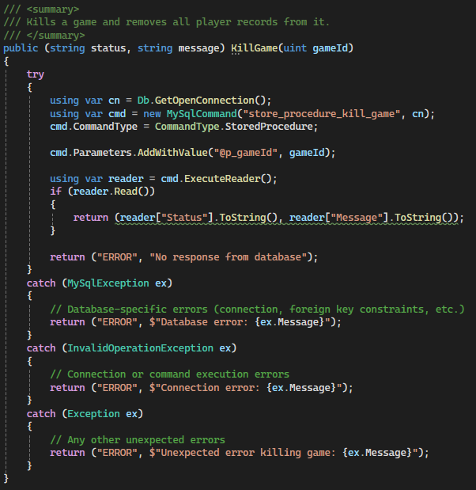

**How Stored Procedure Data is Used:**

The stored procedure store_procedure_kill_game returns a result set with Status and Message columns. The DAO extracts these using ExecuteReader():

* **Status = 'SUCCESS'**: Game killed, all players removed
* **Status = 'ERROR'**: Kill failed (game doesn't exist, database error)

This is an admin-only function accessed through the AdminForm.

**Exception Handling:**

Three catch blocks:

* MySqlException: Database errors (connection issues, foreign key constraint problems)
* InvalidOperationException: Connection or command execution errors
* Exception: Unexpected errors

All exceptions return error tuples with descriptive messages for the administrator.

##### Process 10: Admin Add Player

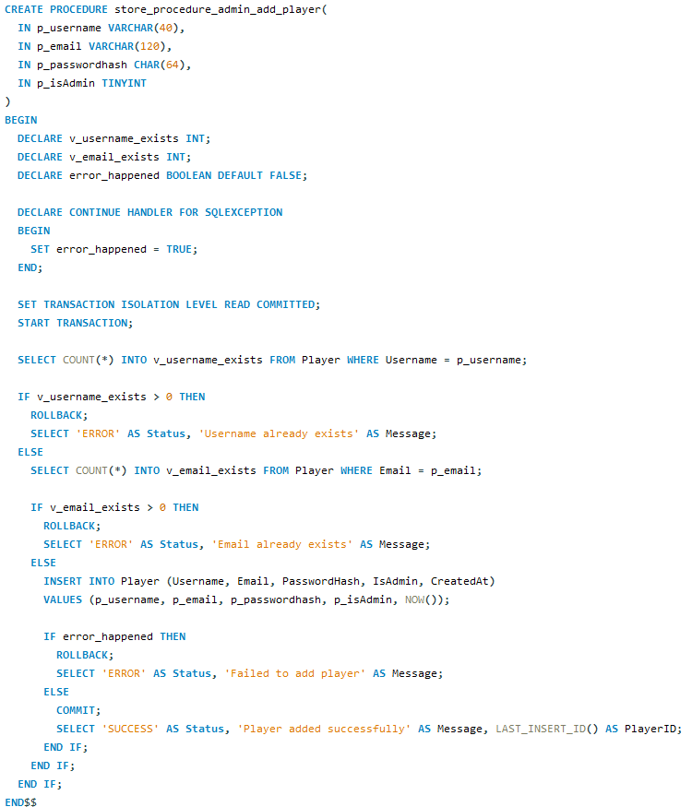

**Transaction Management:** Uses READ COMMITTED isolation level for administrative player creation.

**Error Handling:** Implements DECLARE CONTINUE HANDLER FOR SQLEXCEPTION with error_happened flag.

**Validation Logic:** Similar to registration procedure, but admin can set the IsAdmin flag:

1. Checks if username already exists (v_username_exists)
2. Checks if email already exists (v_email_exists)

Only proceeds with INSERT if both checks pass.

**Difference from Registration:** Unlike regular registration which always creates non-admin accounts, this procedure accepts p_isAdmin parameter allowing administrators to create other admin accounts.

**Result Set:** Returns Status ('SUCCESS' or 'ERROR'), Message (specific error or success message), and PlayerID (LAST_INSERT_ID() when creation succeeds).

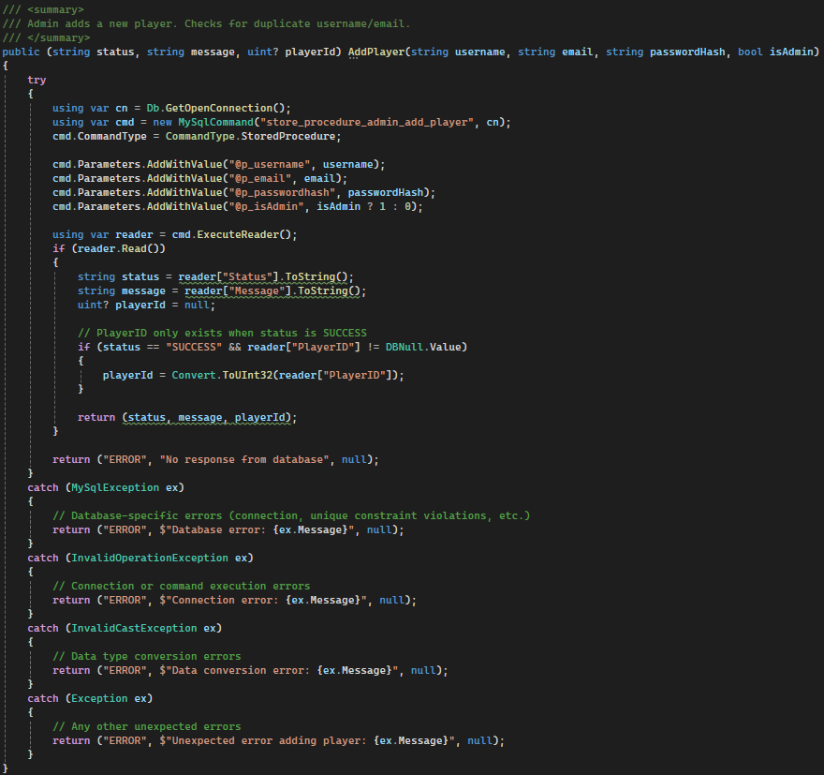

**How Stored Procedure Data is Used:**

The stored procedure store_procedure_admin_add_player returns a result set with Status, Message, and PlayerID columns. The DAO extracts these using ExecuteReader():

* **Status = “SUCCESS”**: Player created, PlayerID contains new player's ID
* **Status = “ERROR”**: Creation failed (username exists, email exists, database error)

The tuple return type (string status, string message, uint? playerId) allows the GUI to display the new player's ID on success or specific error on failure.

**Exception Handling:**

Four catch blocks:

* MySqlException: Database errors (connection issues, unique constraint violations)
* InvalidOperationException: Connection or command execution errors
* InvalidCastException: Data type conversion errors
* Exception: Unexpected errors

All exceptions return error tuples.

##### Process 11: Admin Update Player

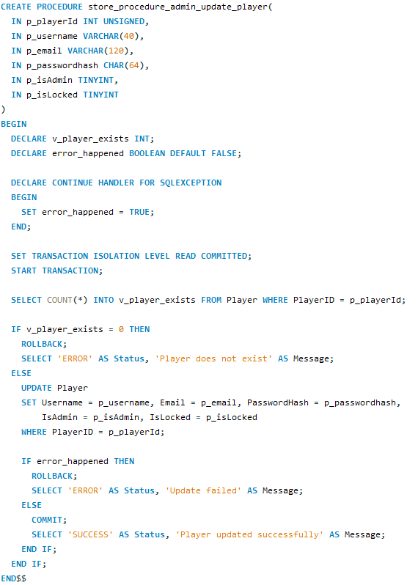

**Transaction Management:** Uses READ COMMITTED isolation level for administrative updates.

**Error Handling:** Implements DECLARE CONTINUE HANDLER FOR SQLEXCEPTION with error_happened flag.

**Validation Logic:** Before updating, checks if the player exists (SELECT COUNT into v_player_exists).

**Operations:** If player exists, executes UPDATE statement that modifies all player fields:

* Username
* Email
* PasswordHash
* IsAdmin (can promote/demote admin status)
* IsLocked (can unlock locked accounts)

**Use Cases:** This procedure allows administrators to:

* Reset passwords for users who forgot them
* Unlock accounts that were locked due to failed login attempts
* Change admin privileges
* Update user information

**Result Set:** Returns Status (“SUCCESS” or “ERROR”) and Message describing the outcome.

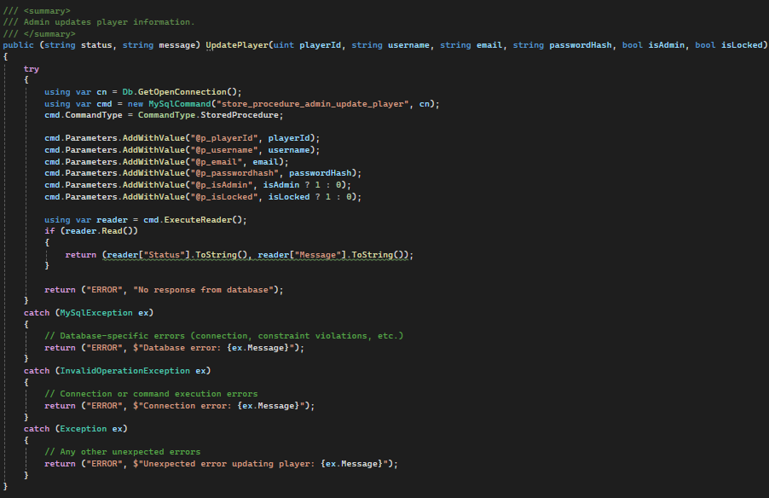

**How Stored Procedure Data is Used:**

The stored procedure store_procedure_admin_update_player returns a result set with Status and Message columns. The DAO extracts these using ExecuteReader():

* **Status = “SUCCESS”**: Player updated successfully
* **Status = “ERROR”**: Update failed (player doesn't exist, database error)

The method accepts six parameters: playerId, username, email, passwordHash, isAdmin, and isLocked, allowing complete control over the player account.

**Exception Handling:**

Three catch blocks:

* MySqlException: Database errors (connection issues, constraint violations if new username/email conflicts)
* InvalidOperationException: Connection or command execution errors
* Exception: Unexpected errors

All exceptions return error tuples with descriptive messages.

##### Process 12: Admin Delete Player

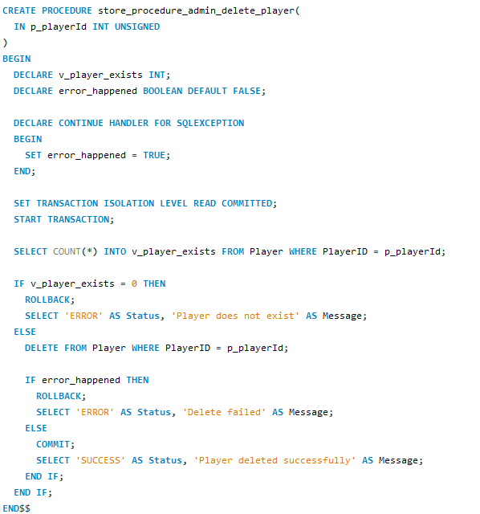

**Transaction Management:** Uses READ COMMITTED isolation level for administrative deletions.

**Error Handling:** Implements DECLARE CONTINUE HANDLER FOR SQLEXCEPTION with error_happened flag.

**Validation Logic:** Before deleting, checks if the player exists (SELECT COUNT into v_player_exists). This validation provides a meaningful error message if trying to delete a non-existent player, rather than silently succeeding.

**Operations:** If player exists, executes DELETE FROM Player WHERE PlayerID = p_playerId.

**Cascade Effects:** Due to foreign key constraints with ON DELETE CASCADE:

* Deleting Player cascades to PlayerGame records
* Which cascades to Inventory records

This ensures complete cleanup of all player-related data across the database.

**Result Set:** Returns Status (“SUCCESS” or “ERROR”) and Message describing the outcome.

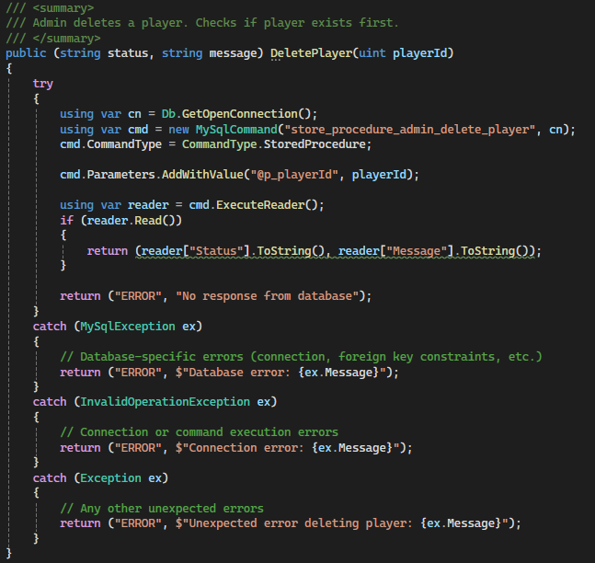

**How Stored Procedure Data is Used:**

The stored procedure store_procedure_admin_delete_player returns a result set with Status and Message columns. The DAO extracts these using ExecuteReader():

* **Status = 'SUCCESS'**: Player deleted successfully along with all related records
* **Status = 'ERROR'**: Deletion failed (player doesn't exist, database error)

This is a destructive operation, so the DAO should be called carefully and typically after user confirmation.

**Exception Handling:**

Three catch blocks:

* MySqlException: Database errors (connection issues, foreign key constraint problems)
* InvalidOperationException: Connection or command execution errors
* Exception: Unexpected errors

All exceptions return error tuples with descriptive messages for the administrator.

## 2. Concurrency Management in MySQL

## Introduction

When multiple players access a game database at the same time, there is a real risk that their actions might interfere with each other. For example, if two players try to pick up the same item simultaneously or if two players attempt to move onto the same tile the database needs a way to handle these conflicts without losing data or creating inconsistencies (Conolly & Begg, 2015). This is what we call the concurrency problem in database systems.

Concurrency control referes to the techniques that databases use to manage simultaneous access by multiple users while maintaining data integrity (Elmasri & Navathe, 2016). Without proper concurrency control, several problems can occur. A lost update happens when two transactions read the same data and then update it based on the value they read, causing one update to overwrite the other (Ramakrishnan & Gehrke, 2003). Dirty reads occur when a transaction reads data that another transaction has modified but not yet committed which could lead to reading incorrect information if that other transaction gets rolled back. Phantom reads happen when a transaction reads a set of rows that satisfy a condition, but a second read returns different rows because another transaction has inserted or deleted rows in the meantime (Garcia-Molina et al., 2009).

This report examines three major approaches to handling concurrency called pessimistic locking, optimistic locking, and timestamp ordering, and then explains why I chose to use a certain transaction isolation levels for The Raze game database. Each approach has its own strengths and weaknesses and the best choice depends on the specific requirements of the application.

## Pessimistic Locking

Pessimistic locking takes a cautious approach by assuming that conflicts between transactions are likely to occur (Silberschatz et al., 2020). When a transaction needs to read or modify data, it acquires a lock on that data before accessing it. Other transactions that want to access the same data must wait until the lock is released. This is called "pessimistic" because it assumes the worst - that other transactions will want to modify the same data at the same time.

There are typically two types of locks in pessimistic systems. A shared lock allows multiple transactions to read the same data simultaneously but prevents any of them from modifying it until all shared locks are released (Date, 2004). An exclusive lock on the other hand allows only one transaction to access the data and prevents all other transactions from reading or writing that data until the lock is released. For example, in MySQL you can use SELECT … FOR UPDATE to acquire an exclusive lock on rows or SELECT … LOCK IN SHARE MODE to acquire a shared lock (Oracle Corporation, 2023).

The main advantage of pessimistic locking is that it prevents conflicts before they happen. Once a transaction acquires a lock it can be confident that no other transaction will interfere with its data (Bernstein et al., 1987). This makes the approach straightforward to understand and implement. However, pessimistic locking has significant drawbacks. When transactions must wait for locks to be released, the system slows down particularly in high-traffic environments where many users are trying to access the same data (Gray & Reuter, 1993). Even worse, deadlocks can occur when two transactions are each waiting for the other to release a lock, causing both to be stuck indefinitely. Database systems typically handle this by detecting deadlocks and rolling back one of the transactions, but this still wastes processing time and can frustrate users if their actions get cancelled.

In a game like The Raze, pessimistic locking would be problematic. If a player tries to move to a tile and the system locks that tile, other players cannot even check if the tile is available until the first player completes their move. This would create noticeable delays in gameplay, especially during busy periods when many players are moving around the board simultaneously.

## Optimistic Locking

Optimistic locking takes the opposite approach by assuming that conflicts are rare (Kung & Robinson, 1981). Instead of locking data when reading it, transactions proceed freely and only check for conflicts when they are ready to commit their changes. This is called “optimistic” because it assumes the best that most of the time, transactions will not interfere with each other.

The typical implementation adds a version number or timestamp column to database tables (Bernstein & Goodman, 1983). When a transaction reads a row, it notes the current version number. When it tries to update that row it checks whether the version number is still the same. If another transaction has modified the row in the meantime, the version number will have changed and the update is rejected. The application must then decide how to handle this usually by re-reading the data and trying again. For instance, a Player table might include a Version column that increments with each update, and the update statement would include WHERE Version = @originalVersion to ensure no changes occurred since reading the data.

The main advantage of optimistic locking is performance in low-conflict scenarios. Since transactions do not wait for locks, read operations are very fast, and the system can handle many concurrent users efficiently as long as they are mostly reading data rather than updating the same records (Haerder & Reuter, 1983). This approach is popular in web applications where read operations far outnumber writes such as viewing product listings in an online store.

However, optimistic locking has drawbacks in high-conflict situations. When conflicts do occur, transactions fail and must retry which wastes the work they have already done. If conflicts are frequent, the system might spend more time retrying failed transactions than it would have spent waiting for locks in a pessimistic system (Thomasian, 1998). Additionally, implementing optimistic locking requires more complex application code to handle retry logic and users might see error messages telling them to try their action again if someone else modified the data first.

For The Raze, optimistic locking would be suitable for some operations like updating a players profile information where conflicts are rare. However, for game actions like picking up items or moving to tiles, conflicts are more common because multiple players might target the same resources, making optimistic locking less appropriate.

## Timestamp Ordering

Timestamp ordering is a different approach that avoids locks entirely by assigning each transaction a unique timestamp when it begins (Bernstein & Goodman, 1980). The database system then ensures that transactions execute in timestamp order as if they had run one after another in that sequence even though they might actually execute concurrently. This creates what is called a serializable schedule meaning the result is the same as if the transactions had executed serially.

Each data item in the database stores two timestamps, the timestamp of the last transaction that read it and the timestamp of the last transaction that wrote it (Reed, 1983). When a transaction wants to read or write data, the system compares the transaction's timestamp with these stored timestamps. If the transactions timestamp is older than the write timestamp on the data, it means a newer transaction has already modified that data, so the system rejects this transaction and forces it to restart with a new timestamp. Similarly, if a transaction tries to write data that a newer transaction has already read the write is rejected to maintain consistency.

The advantage of timestamp ordering is that transactions never wait for locks which eliminates deadlocks entirely and can provide good performance when conflicts are not too common (Kumar, 1996). The system automatically enforces a consistent ordering of operations without requiring explicit lock management.

However, timestamp ordering has significant disadvantages. The overhead of maintaining and checking timestamps on every operation can slow down the system (Thomasian, 1993). More importantly, when conflicts are detected, transactions must be aborted and restarted, which wastes all the work they have done so far. In high-conflict scenarios this can lead to frequent restarts, severely degrading performance. The approach also requires more complex implementation in the database system itself, which is why it is less commonly used in practice than locking-based approaches.

For a game database like The Raze, timestamp ordering would be problematic because game actions often involve multiple players targeting the same resources (tiles, items, and scores), leading to frequent conflicts and transaction restarts. This would create a poor user experience with unpredictable delays and failed actions.

**My Chosen Approach: Transaction Isolation Levels**

For my game, I chose to use MySQL's built-in transaction isolation levels rather than implementing explicit locking or timestamp ordering at the application level. Transaction isolation levels provide a standardized way to control concurrency that is supported directly by the database system and can be adjusted per transaction based on the specific requirements of each operation (Microsoft Corporation, 2023).

MySQL supports four isolation levels defined in the SQL standard, Read Uncommitted, Read Committed, Repeatable Read, and Serializable (Gulutzan & Pelzer, 1999). Read Uncommitted provides the least protection allowing dirty reads but offering the best performance. Read Committed prevents dirty reads by ensuring that transactions only see committed data from other transactions which is suitable for most standard operations. Repeatable Read goes further by ensuring that if a transaction reads a row multiple times it always sees the same data, preventing non-repeatable reads. Serializable provides the highest level of isolation by preventing phantom reads and ensuring that transactions execute as if they were running one after another, though at the cost of reduced concurrency.

In my implementation, I selected the appropriate isolation level for each stored procedure based on the risk of conflicts and the need for consistency. For login and admin operations, I used Read Committed because these operations typically access different user records and conflicts are rare. A player logging in does not interfere with another players login so there is no need for stronger isolation that would reduce performance unnecessarily.

For player movement operations, I used Repeatable Read to prevent tile conflicts. When a player moves to a tile, the procedure checks if the tile is occupied, and then updates the player's position. If another player is simultaneously trying to move to the same tile, Repeatable Read ensures that each transaction sees a consistent view of the board and prevents both players from ending up on the same tile. The code example shows this implementation:

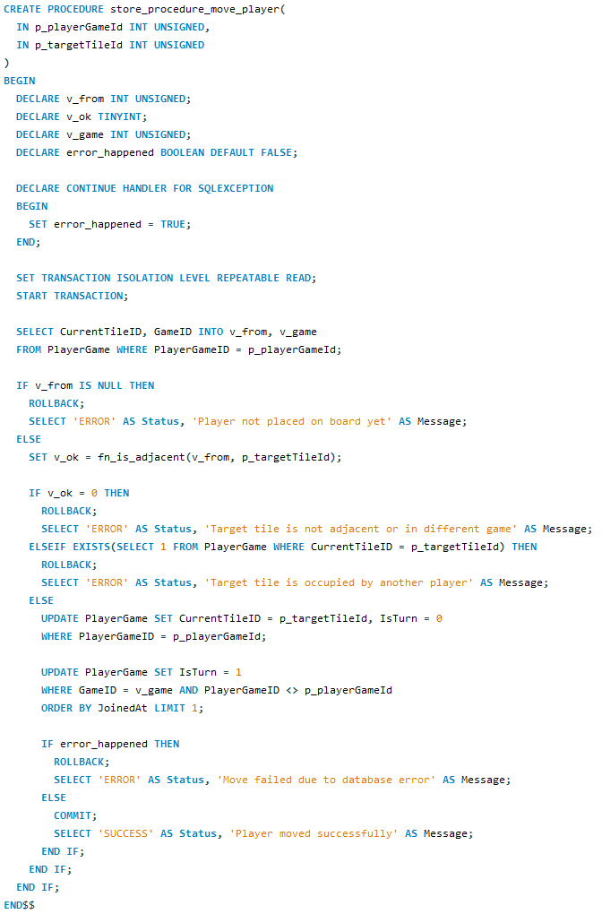

For scoring and item pickup operations, I used Serializable isolation to prevent race conditions that could lead to lost updates. Consider a scenario where two players simultaneously pick up items that give points. Without proper isolation, both transactions might read the current score, add their points, and write back the new total, causing one update to overwrite the other and losing points. Serializable isolation prevents this by ensuring that these operations execute one at a time, guaranteeing that all points are correctly added to the score (Berenson et al., 1995).

The advantages of this approach are significant. First, isolation levels are standardized and built into MySQL, so I do not need to write complex locking code or version-checking logic in my application. Second, I can tune the concurrency control per operation, using lighter isolation where conflicts are rare and stronger isolation where data integrity is critical. This provides better performance than applying the same strict control to all operations. Third, the database system handles all the details of locking and ensuring consistency, reducing the chance of bugs in my application code.

There are some drawbacks to consider. Stronger isolation levels like Serializable can reduce concurrency and performance because transactions may need to wait for each other. However, I mitigated this by only using Serializable for the operations that truly need it, such as scoring, while using lighter isolation for other operations. Additionally, with isolation levels, the application still needs to handle the possibility that a transaction might fail due to conflicts, but MySQL makes this straightforward by rolling back failed transactions and returning an error that the application can catch and handle gracefully.

## Concurrency Management in .NET C# Database Connections

While MySQL provides transaction isolation levels at the database layer, .NET C# offers additional concurrency management approaches at the application layer through data access technologies like LINQ and Entity Framework (Microsoft Corporation, 2023a). Understanding how these technologies handle concurrent access is essential for choosing the right architecture for a database application.

**Direct ADO.NET with Stored Procedures**

In The Raze project, I used direct ADO.NET connections with stored procedures, which is the approach demonstrated in the C# DAO classes. This method gives the application explicit control over transaction management and relies heavily on the database's built-in concurrency mechanisms. Each DAO method opens a connection, calls a stored procedure, and lets MySQL handle the transaction isolation and locking (Esposito & Saltarello, 2014).

The code example shown below shows this pattern:

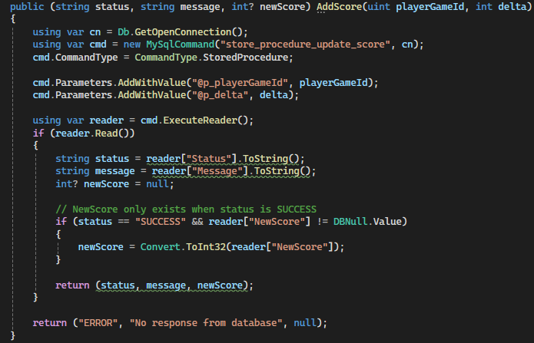

This approach provides several advantages. The business logic and concurrency control remain centralized in the database layer, making it easier to maintain consistency across different applications that might access the same database (Troelsen & Japikse, 2022). The stored procedures can be optimized by database administrators without requiring application code changes, and the explicit transaction boundaries in SQL make it clear where concurrency control occurs.

However, this approach also has limitations. The application code cannot easily implement optimistic concurrency without additional database schema changes like version columns, and complex business logic split between C# and SQL can become harder to test and debug (Lerman & Miller, 2020).

## LINQ to SQL Connections

LINQ (Language Integrated Query) provides an alternative approach by allowing developers to write database queries directly in C# using a syntax that resembles object manipulation (Albahari & Albahari, 2022). LINQ to SQL, while now considered legacy technology, demonstrates important concepts about application-layer concurrency management.

With LINQ to SQL, developers work with objects that represent database tables, and the framework automatically generates SQL queries based on C# code. For concurrency management, LINQ to SQL primarily uses optimistic concurrency control (Microsoft Corporation, 2012). Each entity class includes a timestamp or version column and when an update occurs LINQ checks whether the database row has changed since it was read. If another transaction has modified the row the update throws a ChangeConflictException that the application must handle.

To illustrate how this approach differs from my implementation, consider how score updates would work with LINQ to SQL. The developer would load a player object, modify its score property, and call SubmitChanges(). The framework would automatically generate an UPDATE statement that includes a WHERE clause checking the version column. If another transaction modified the player record between the read and update, the WHERE clause would match zero rows and LINQ would throw a ChangeConflictException. The application code would then need to catch this exception, reload the current data from the database, reapply the score change to the fresh data, and retry the update (Albahari & Albahari, 2022).

The advantage of LINQ's optimistic approach is that it works well in scenarios where conflicts are rare, such as updating player profile information. Multiple users can read and modify different records simultaneously without waiting for locks providing good performance in low-contention environments. Additionally, because the concurrency checking happens at the application layer, developers can implement sophisticated conflict resolution strategies such as presenting the user with both versions of the data and asking them to choose which changes to keep.

The disadvantages become apparent in high-contention scenarios like game mechanics where multiple players frequently target the same resources. In The Raze, if two players simultaneously tried to pick up the same item using LINQ's optimistic concurrency one transaction would fail and need to retry potentially leading to a poor user experience. Furthermore, LINQ to SQL requires additional columns in the database schema specifically for version tracking which adds overhead to every table and increases storage requirements (Lerman & Miller, 2020). This is why I chose not to implement LINQ to SQL for The Raze, the game's high-conflict nature makes optimistic concurrency inappropriate for core mechanics.

## Entity Framework Connections

Entity Framework (EF) represents Microsoft's current recommended approach for .NET database access and provides more sophisticated concurrency management options than LINQ to SQL (Microsoft Corporation, 2023b). Like LINQ to SQL, Entity Framework primarily uses optimistic concurrency but it offers more flexibility in how conflicts are detected and resolved.

Entity Framework supports three concurrency token types, timestamp/rowversion columns that the database updates automatically, properties marked with ConcurrencyCheck attributes, and complete row versioning where all columns are checked for changes (Lerman & Miller, 2020). When a conflict occurs, EF throws a DbUpdateConcurrencyException that provides detailed information about which properties were in conflict allowing for granular resolution strategies.

To understand why I did not choose Entity Framework for The Raze, it is helpful to consider how it would handle a common game scenario. When a player picks up an item that grants points, Entity Framework would load the player entity, modify the score property, and call SaveChanges(). Behind the scenes, EF generates an UPDATE statement with concurrency checking based on the configured concurrency tokens. If another player's transaction has already modified the same player record - perhaps by picking up a different item - Entity Framework would detect the conflict through the changed concurrency token and throw a DbUpdateConcurrencyException (Microsoft Corporation, 2023b).

The application would then need to handle this exception which typically involves reloading the current database values determining how to merge the conflicting changes and retrying the save operation. Entity Framework provides methods like GetDatabaseValuesAsync() to retrieve the current database state and SetValues() to update the entity with fresh data. However, implementing correct conflict resolution logic can become complex especially when multiple properties might be in conflict simultaneously (Lerman & Miller, 2020).

Entity Framework's advantages include its mature tooling and integration with Visual Studio, comprehensive documentation and community support and flexible concurrency strategies that can be configured per entity type (Troelsen & Japikse, 2022). The framework also provides async/await support for better scalability in web applications and it can automatically handle many conflict resolution scenarios without complex application code.

However, Entity Framework has significant drawbacks for game database applications like The Raze. The optimistic concurrency model struggles with high-contention scenarios where multiple players frequently access the same data. When two players simultaneously pick up items that both grant points, one player's action would fail with a concurrency exception requiring retry logic that could frustrate users. The frameworks change tracking overhead can impact performance particularly when working with large numbers of entities, and complex queries sometimes result in inefficient SQL that performs worse than hand-written stored procedures (Lerman & Miller, 2020). Additionally, debugging concurrency issues can be more difficult because the generated SQL is hidden from the developer unless explicitly logged.

For these reasons, The Raze uses direct ADO.NET connections with storedprocedures rather than Entity Framework. The stored procedure approach allows precise control over concurrency through transaction isolation levels, eliminating the need for retry logic and ensuring consistent behaviour under high load.

## Comparison: MySQL Stored Procedures vs .NET Approaches

Comparing these approaches reveals important trade-offs. MySQL transaction isolation levels provide deterministic concurrency control with predictable performance characteristics, while .NET's optimistic concurrency offers better performance in low-contention scenarios but requires retry logic and can fail under high contention (Esposito & Saltarello, 2014).

For The Raze game, the stored procedure approach proved more appropriate because game mechanics involve frequent conflicts and multiple players targeting the same tiles, items, and score updates. Using Serializable isolation for score updates guarantees that no points are lost even when multiple players simultaneously pick up items. In contrast, an Entity Framework approach with optimistic concurrency would require retry logic for every score update and players might experience failed actions that they would need to repeat (Troelsen & Japikse, 2022).

However, Entity Framework or LINQ might be better choices for other parts of a game system. For example, player profile management, friend lists, and achievement tracking involve relatively independent data that different players modify. Here, optimistic concurrency works well because conflicts are not so common and the frameworks productivity benefits outweigh the occasional conflict that requires a retry (Lerman & Miller, 2020).

The choice between approaches also depends on team expertise and project requirements. Stored procedures require database skills and make business logic harder to unit test while Entity Framework allows more application logic to be written in C# where it can be easily tested (Microsoft Corporation, 2023b). For The Raze, I prioritized data integrity and performance for core game mechanics by using stored procedures, while accepting the trade-off of maintaining SQL code separately from C# code.

A hybrid approach might offer the best of both worlds. Core game mechanics that require strict consistency and high concurrency could use stored procedures with transaction isolation levels, while less critical features like player profiles and settings could use Entity Framework for faster development and easier maintenance (Esposito & Saltarello, 2014). This architectural pattern is commonly seen in production game servers where performance-critical code paths are optimized separately from general-purpose features.

## Conclusion

After examining pessimistic locking, optimistic locking, and timestamp ordering, as well as comparing database-layer concurrency management in MySQL with application-layer approaches in .NET C#, I concluded that transaction isolation levels in MySQL stored procedures provide the best solution for The Raze game database.

Pessimistic locking would create too many delays in gameplay by forcing players to wait for locks to be released. Optimistic locking, whether implemented through LINQ to SQL or Entity Framework, would work well for some operations but would require complex retry logic in the application and could lead to frustration when conflicts occur during critical game actions. Timestamp ordering would eliminate deadlocks but at the cost of frequent transaction restarts and implementation complexity.

The comparison between MySQL stored procedures and .NET approaches revealed that while Entity Framework and LINQ offer productivity benefits and work well for low-contention scenarios, they struggle with the high-conflict environment of real-time game mechanics. The Raze's requirements for strict consistency in score updates, tile occupancy, and item distribution made database-layer concurrency control through transaction isolation levels the most appropriate choice.

Transaction isolation levels offer a practical solution that balances performance and data integrity. They are built into MySQL and require minimal application code, while still providing precise control over concurrency through the choice of isolation level for each operation. By using Read Committed for routine operations, Repeatable Read for movement, and Serializable for scoring, I achieved a balance that is appropriate for different types of game actions.

The approach has proven effective in testing, where multiple players can interact with the game simultaneously without data corruption or lost updates, while still maintaining acceptable performance. For future enhancements, a hybrid approach might be considered, using stored procedures with transaction isolation levels for core game mechanics while employing Entity Framework for administrative features and player profile management where optimistic concurrency is sufficient. This demonstrates that choosing the right concurrency control mechanism requires understanding the specific needs of each operation rather than applying a one-size-fits-all solution.

# References

MySQL. (n.d.). *MySQL 8.0 Reference Manual*. <https://dev.mysql.com/doc/>

Microsoft. (n.d.). *C# documentation*. <https://docs.microsoft.com/en-us/dotnet/csharp/>

Berenson, H., Bernstein, P., Gray, J., Melton, J., O'Neil, E., & O'Neil, P. (1995). A critique of ANSI SQL isolation levels. *ACM SIGMOD Record, 24*(2), 1-10. <https://doi.org/10.1145/223784.223785>

Bernstein, P. A., & Goodman, N. (1980). Timestamp-based algorithms for concurrency control in distributed database systems. *Proceedings of the 6th International Conference on Very Large Data Bases*, 285-300.

Bernstein, P. A., & Goodman, N. (1983). Multiversion concurrency control—theory and algorithms. *ACM Transactions on Database Systems, 8*(4), 465-483. <https://doi.org/10.1145/319996.319998>

Bernstein, P. A., Hadzilacos, V., & Goodman, N. (1987). *Concurrency control and recovery in database systems*. Addison-Wesley.

Connolly, T. M., & Begg, C. E. (2015). *Database systems: A practical approach to design, implementation, and management* (6th ed.). Pearson Education.

Date, C. J. (2004). *An introduction to database systems* (8th ed.). Pearson/Addison Wesley.

Elmasri, R., & Navathe, S. B. (2016). *Fundamentals of database systems* (7th ed.). Pearson.

Garcia-Molina, H., Ullman, J. D., & Widom, J. (2009). *Database systems: The complete book* (2nd ed.). Pearson Prentice Hall.

Gray, J., & Reuter, A. (1993). *Transaction processing: Concepts and techniques*. Morgan Kaufmann.

Gulutzan, P., & Pelzer, T. (1999). *SQL-99 complete, really*. CMP Books.

Haerder, T., & Reuter, A. (1983). Principles of transaction-oriented database recovery. *ACM Computing Surveys, 15*(4), 287-317. <https://doi.org/10.1145/289.291>

Kumar, V. (1996). Performance of concurrency control mechanisms in centralized database systems. *Prentice Hall*.

Kung, H. T., & Robinson, J. T. (1981). On optimistic methods for concurrency control. *ACM Transactions on Database Systems, 6*(2), 213-226. <https://doi.org/10.1145/319566.319567>

Microsoft Corporation. (2023). *Transaction isolation levels*. Microsoft SQL Server Documentation. <https://learn.microsoft.com/en-us/sql/t-sql/statements/set-transaction-isolation-level-transact-sql>

Oracle Corporation. (2023). *MySQL 8.0 reference manual: InnoDB locking*. <https://dev.mysql.com/doc/refman/8.0/en/innodb-locking.html>

Ramakrishnan, R., & Gehrke, J. (2003). *Database management systems* (3rd ed.). McGraw-Hill.

Reed, D. P. (1983). Implementing atomic actions on decentralized data. *ACM Transactions on Computer Systems, 1*(1), 3-23. <https://doi.org/10.1145/357353.357355>

Silberschatz, A., Korth, H. F., & Sudarshan, S. (2020). *Database system concepts* (7th ed.). McGraw-Hill Education.

Thomasian, A. (1993). Distributed optimistic concurrency control methods for high-performance transaction processing. *IEEE Transactions on Knowledge and Data Engineering, 5*(5), 710-724. <https://doi.org/10.1109/69.243504>

Thomasian, A. (1998). Concurrency control: Methods, performance, and analysis. *ACM Computing Surveys, 30*(1), 70-119. <https://doi.org/10.1145/274440.274443>

Albahari, J., & Albahari, B. (2022). *C# 10 in a nutshell: The definitive reference*. O'Reilly Media.

Esposito, D., & Saltarello, A. (2014). *Microsoft .NET: Architecting applications for the enterprise* (2nd ed.). Microsoft Press.

Lerman, J., & Miller, R. (2020). *Programming Entity Framework: DbContext*. O'Reilly Media.

Microsoft Corporation. (2012). *LINQ to SQL: .NET language-integrated query for relational data*. Microsoft Developer Network. <https://learn.microsoft.com/en-us/dotnet/framework/data/adonet/sql/linq/>

Microsoft Corporation. (2023a). *ADO.NET overview*. Microsoft Learn. <https://learn.microsoft.com/en-us/dotnet/framework/data/adonet/ado-net-overview>

Microsoft Corporation. (2023b). *Entity Framework Core*. Microsoft Learn. <https://learn.microsoft.com/en-us/ef/core/>

Troelsen, A., & Japikse, P. (2022). *Pro C# 10 with .NET 6: Foundational principles and practices in programming* (11th ed.). Apress.